CoP SAP 6.4

Allyson Mateja September 21, 2026
  - Prediction of Post-Challenge Viral Load with Single Virus-Specific Antibody
The first step is to predict a post-challenge viral load (chosen from Section 3.3) using a virus-specific antibody (from Section 3.2). Different models are used depending on whether the post-challenge viral load is binary or numeric.

Numeric Viral Load
For numeric viral load, several models will be fit using the log of the response value. Let y_{jk} and x_{jk} be the outcome (e.g., log of the viral load) and the virus-specific antibody, respectively, for the k^{th} animal in the j^{th} arm. Let µ_{jk} be the mean response associated with y_{jk}. For this model, the vaccine arm is not modeled, so that two animals from different vaccine arms with the same value of virus-specific antibody will have the same predicted response. Several different models will be fit to the data, and best model will be selected by repeated cross validation with 500 replicates, where a certain proportion of the animals (e.g., 10%) are randomly left out of the model building and those left-out animals will be used to compare the fits of different models by adjusted R-squared. The animals selected for the test set will be stratified by challenge day; 1-2 animals will be selected per challenge day with the added constraint that both animals selected from a given day will not both be placebo.
The simplest model tried will be the linear model: µ_{jk} = β₀ + β₁x_{jk}. Another model is an exponential model (see e.g., McMahan, et al, 2020, Fig. 2). A third set of models are segmented regression models, with 2 breakpoints, using the segmented R package (Muggeo, 2020). A fourth set of models are fit with natural cubic splines with 5 degrees of freedom, using the default knots in the ns function in the spline R package. Finally, a four parameter logistic (4-PL) model may also be evaluated using the drm function in the drc R package (Ritz et al., 2015): µ_{jk} = B + ((A − B)/(1 + (x_{jk}/C)D)), where the 4-PL parameters are: A = lower asymptote, B = upper asymptote, C = midpoint, D = slope parameter. That model will be fit by least squares and the BFGS optimization method.
f (x) = c + 1+exp( d−c
b(log(x)−log(e)))
If the cross-validation produces a model with substantial non-monotonicity, we may remove that model type from consideration and repeat the CV without that model. This process may be repeated if necessary.
Once the model is selected by cross validation, the selected model will be fit to all of the data. If the selected model is not segmented regression, pointwise confidence intervals on the predicted values will be calculated using the parametric formula: yˆ_{jk} ± t_{α/2,df} SE, where yˆ_{jk} = the estimated predicted value for the k^{t}h animal in the j^{t}h arm, SE = the standard error for the estimate of the predicted value, and t_{α/2,df} = critical value from the t distribution corresponding to α/2 and n-p degrees of freedom (p includes the intercept, where applicable). This is analogous to the built-in predict functions in R. If the segmented regression model is selected by the cross-validation procedure, pointwise confidence intervals on the predicted values will be calculated by nonparametric bootstrap.

Antibody to Predict Post Challenge Viral Load - Numeric

Antibody
Virus-Specific | Viral Load | Model Selected | Adjusted Rsq | Figure Number
log MN day | AUC BAL N1 | exp | 0.526 | 6.4.2
challenge
log PsVNA ID80 day challenge  log PsVNA ID80 | AUC Nasal Swab  AUC Nasal Swab | lm  lm | 0.508  0.504 | 6.4.32  6.4.24
day challenge  log MN 2 weeks | N1  AUC Nasal Swab | lm | 0.498 | 6.4.25
prior challenge  log MN 2 weeks | Subgenomic  AUC Nasal Swab | lm | 0.478 | 6.4.17
prior challenge | N1
log PsVNA ID80 | AUC Nasal Swab | lm | 0.477 | 6.4.31
2 weeks prior | Subgenomic
challenge
log MSD ECL day challenge  log MN day | AUC Nasal Swab  AUC Nasal Swab | lm  lm | 0.476  0.473 | 6.4.20  6.4.26
challenge  log PsVNA ID80 | Subgenomic  log VL Day2 | lm | 0.462 | 6.4.88
day challenge  log MSD ECL 2 | PostChallenge  AUC Nasal Swab | lm | 0.460 | 6.4.19
weeks prior | N1
challenge
log MSD ECL 2 | log VL Day2 | 4pl | 0.460 | 6.4.83
weeks prior challenge  log MSD ECL day | PostChallenge  AUC BAL N1 | lm | 0.452 | 6.4.4
challenge
log PsVNA ID80 | AUC Nasal Swab | lm | 0.451 | 6.4.23
2 weeks prior | N1
challenge
log PsVNA ID80 | log VL Day2 | lm | 0.450 | 6.4.87
2 weeks prior challenge log MN day | PostChallenge  AUC Nasal Swab | lm | 0.449 | 6.4.18
challenge | N1
log PsVNA ID50 | AUC Nasal Swab | exp | 0.447 | 6.4.29
2 weeks prior  log MSD ECL day | Subgenomic  AUC Nasal Swab | lm | 0.445 | 6.4.28
challenge | Subgenomic

Subgenomic

N1

NasalSwab N1

NasalSwab N1

NasalSwab N1

challenge

log PsVNA ID50 2 weeks prior challenge
log VL Day2 PostChallenge NasalSwab N1
lm 0.444 6.4.85

Antibody
Virus-Specific | Viral Load | Model Selected | Adjusted Rsq | Figure Number
log PsVNA ID80 | log VL Day2 | lm | 0.444 | 6.4.95
2 weeks prior | PostChallenge
challenge  log MN 2 weeks | NasalSwab  log VL Day2 | lm | 0.442 | 6.4.89
prior challenge | PostChallenge
 | NasalSwab
 | Subgenomic
log MSD ECL 2 | AUC Nasal Swab | lm | 0.438 | 6.4.27
weeks prior | Subgenomic

Subgenomic

challenge
log PsVNA ID80 day challenge

log VL Day2 PostChallenge NasalSwab Subgenomic
log MN 2 weeks | log VL Day2 | lm | 0.436 | 6.4.81
prior challenge  log MN day | PostChallenge  AUC BAL | exp | 0.431 | 6.4.10
challenge  log PsVNA ID50 | Subgenomic  log VL Day2 | exp | 0.430 | 6.4.93
2 weeks prior | PostChallenge
challenge | NasalSwab
 | Subgenomic
log PsVNA ID50 | AUC Nasal Swab | lm | 0.428 | 6.4.21
2 weeks prior | N1
challenge
log PsVNA ID50 day challenge log MSD ECL 2 | AUC Nasal Swab  AUC BAL N1 | lm  lm | 0.428  0.412 | 6.4.22  6.4.3
weeks prior  log PsVNA ID50 | AUC Nasal Swab | lm | 0.409 | 6.4.30
day challenge  log MSD ECL day | Subgenomic  AUC BAL | lm | 0.397 | 6.4.12
challenge | Subgenomic
log MN 2 weeks | AUC BAL N1 | exp | 0.394 | 6.4.1
prior challenge
log PsVNA ID50 | log VL Day2 | exp | 0.390 | 6.4.86
day challenge | PostChallenge

lm 0.438 6.4.96

NasalSwab N1

N1

challenge

log PsVNA ID50 day challenge
NasalSwab N1 log VL Day2 PostChallenge NasalSwab Subgenomic
exp 0.372 6.4.94

Antibody
Virus-Specific | Viral Load | Model Selected | Adjusted Rsq | Figure Number
log MN day | log VL Day2 | lm | 0.371 | 6.4.82
challenge  log MN day | PostChallenge  log VL Day2 | lm | 0.370 | 6.4.90
challenge | PostChallenge
 | NasalSwab
 | Subgenomic
log PsVNA ID80 | AUC BAL N1 | exp | 0.368 | 6.4.8

NasalSwab N1

day challenge log MSD ECL 2 weeks prior challenge

log VL Day2 PostChallenge NasalSwab Subgenomic
log MSD ECL day | AUC OP Swab N1 | lm | 0.362 | 6.4.36
challenge
log PsVNA ID80 | AUC OP Swab N1 | lm | 0.360 | 6.4.40
day challenge
log MSD ECL 2 | AUC OP Swab N1 | lm | 0.348 | 6.4.35
weeks prior
challenge
log MSD ECL day | log VL Day2 | lm | 0.348 | 6.4.84
challenge  log MSD ECL 2 | PostChallenge  AUC BAL | lm | 0.346 | 6.4.11
weeks prior | Subgenomic
challenge
log PsVNA ID80 | AUC BAL N1 | exp | 0.340 | 6.4.7
2 weeks prior  log MN day | log VL Day2 | lm | 0.340 | 6.4.50
challenge  log MSD ECL day | PostChallenge  log VL Day2 | lm | 0.336 | 6.4.92
challenge | PostChallenge
 | NasalSwab
 | Subgenomic
log MN day | AUC OP Swab N1 | lm | 0.335 | 6.4.34
challenge
log PsVNA ID80 | AUC OP Swab N1 | lm | 0.331 | 6.4.39
2 weeks prior
challenge
log MN 2 weeks | AUC OP Swab N1 | lm | 0.330 | 6.4.33

lm 0.365 6.4.91

NasalSwab N1

challenge

BAL N1

prior challenge log MN day challenge

log VL Day2 PostChallenge BAL Subgenomic
lm 0.328 6.4.58

Antibody
Virus-Specific | Viral Load | Model Selected | Adjusted Rsq | Figure Number
log PsVNA ID50  challenge | AUC OP Swab N1 | lm | 0.322 | 6.4.37
log MN 2 weeks | AUC BAL | exp | 0.316 | 6.4.9

2 weeks prior

prior challenge log PsVNA ID50 2 weeks prior challenge
log PsVNA ID50 day challenge
Subgenomic
AUC BAL N1 lm 0.308 6.4.5
AUC BAL N1 exp 0.290 6.4.6

log PsVNA ID80 2 weeks prior challenge
log PsVNA ID80 day challenge
log PsVNA ID80 day challenge
log PsVNA ID80 day challenge
log PsVNA ID50 2 weeks prior challenge
log MSD ECL day challenge
log VL Day2 PostChallenge BAL Subgenomic AUC BAL
Subgenomic
log VL Day2 PostChallenge BAL N1
log VL Day2 PostChallenge BAL Subgenomic log VL Day2 PostChallenge BAL N1
log VL Day2 PostChallenge BAL Subgenomic
log PsVNA ID50 2 weeks prior challenge | log VL Day2  BAL Subgenomic | exp | 0.264 | 6.4.61
log MN 2 weeks prior challenge | log VL Day2 | lm | 0.263 | 6.4.57

PostChallenge
lm 0.268 6.4.63
exp 0.267 6.4.16
lm 0.266 6.4.56
exp 0.266 6.4.64
lm 0.265 6.4.53
lm 0.265 6.4.60

log PsVNA ID80 2 weeks prior challenge

PostChallenge BAL Subgenomic log VL Day2 PostChallenge BAL N1

lm 0.259 6.4.55

log PsVNA ID50 day challenge
AUC OP Swab N1 lm 0.255 6.4.38

log MSD ECL day challenge
log PsVNA ID80 2 weeks prior challenge
log MSD ECL day challenge
AUC OP Swab Subgenomic AUC BAL
Subgenomic

log VL Day2 PostChallenge BAL N1
lm 0.253 6.4.44
lm 0.250 6.4.15
lm 0.250 6.4.52

Virus-Specific Antibody
Viral Load Model Selected Adjusted Rsq Figure Number

log MN 2 weeks prior challenge
log MSD ECL 2 weeks prior challenge
log PsVNA ID80 day challenge log MSD ECL 2
weeks prior challenge
log MN 2 weeks prior challenge log MSD ECL 2 weeks prior challenge
log PsVNA ID80 2 weeks prior challenge
log PsVNA ID50 2 weeks prior challenge
log MN day challenge
log PsVNA ID50 day challenge
log PsVNA ID50 2 weeks prior challenge
log PsVNA ID50 day challenge
log PsVNA ID80 day challenge

log PsVNA ID80 2 weeks prior challenge

log MN 2 weeks prior challenge
log VL Day2 PostChallenge BAL N1
log VL Day2 PostChallenge BAL Subgenomic AUC OP Swab Subgenomic AUC OP Swab Subgenomic

AUC OP Swab Subgenomic log VL Day2 PostChallenge BAL N1
AUC OP Swab Subgenomic
AUC OP Swab Subgenomic
AUC OP Swab Subgenomic
log VL Day2 PostChallenge BAL Subgenomic AUC BAL
Subgenomic
log VL Day2 PostChallenge BAL N1
log VL Day2 PostChallenge OPswab Subgenomic log VL Day2 PostChallenge OPswab Subgenomic
log VL Day2 PostChallenge OPswab Subgenomic
lm 0.247 6.4.49
lm 0.243 6.4.59
lm 0.241 6.4.48
lm 0.237 6.4.43
lm 0.236 6.4.41
lm 0.235 6.4.51
lm 0.232 6.4.47
lm 0.228 6.4.45
lm 0.217 6.4.42
exp 0.214 6.4.62
lm 0.210 6.4.13
lm 0.203 6.4.54
lm 0.202 6.4.80
lm 0.200 6.4.79
lm 0.193 6.4.73

log PsVNA ID50 2 weeks prior challenge
log PsVNA ID50 day challenge
log PsVNA ID50 day challenge

log VL Day2 PostChallenge OPswab Subgenomic AUC BAL
Subgenomic log VL Day2 PostChallenge OPswab Subgenomic
log PsVNA ID80 | log VL Day2 | lm | 0.165 | 6.4.72
day challenge | PostChallenge
 | OPswab N1
log MN 2 weeks | log VL Day2 | lm | 0.164 | 6.4.65
prior challenge  log PsVNA ID80 | PostChallenge  log VL Day2 | lm | 0.162 | 6.4.71
2 weeks prior challenge  log PsVNA ID50 | PostChallenge  log VL Day2 | lm | 0.150 | 6.4.69
2 weeks prior challenge  log PsVNA ID50 | PostChallenge  AUC OP Swab | lm | 0.145 | 6.4.46
day challenge  log MSD ECL 2 | Subgenomic  log VL Day2 | lm | 0.136 | 6.4.75
weeks prior | PostChallenge
challenge | OPswab
 | Subgenomic
log MSD ECL day | log VL Day2 | lm | 0.135 | 6.4.76
challenge | PostChallenge
log PsVNA ID50 | OPswab  log VL Day2 | lm | 0.131 | 6.4.70
day challenge | PostChallenge

lm 0.189 6.4.77
exp 0.187 6.4.14
lm 0.174 6.4.78

OPswab N1 OPswab N1 OPswab N1

Subgenomic

log MN day challenge

log MSD ECL day challenge
log MSD ECL 2 weeks prior challenge
OPswab N1 log VL Day2 PostChallenge OPswab Subgenomic log VL Day2 PostChallenge OPswab N1 log VL Day2 PostChallenge OPswab N1
lm 0.127 6.4.74
lm 0.119 6.4.68
lm 0.117 6.4.67

log MN day challenge
log VL Day2 PostChallenge OPswab N1
lm 0.108 6.4.66

There are 79 pairs of virus-specific antibodies/viral loads (out of 96 total pairs) where the best model fit is linear; 16 where the best model fit is exponential; 0 where the best model fit is segmented linear (with 2 breakpoints); 0 where the best model fit is natural cubic splines with 5 degrees of freedom; and 1 where the best model fit is 4-parameter logistic.
Predicted Values
exp
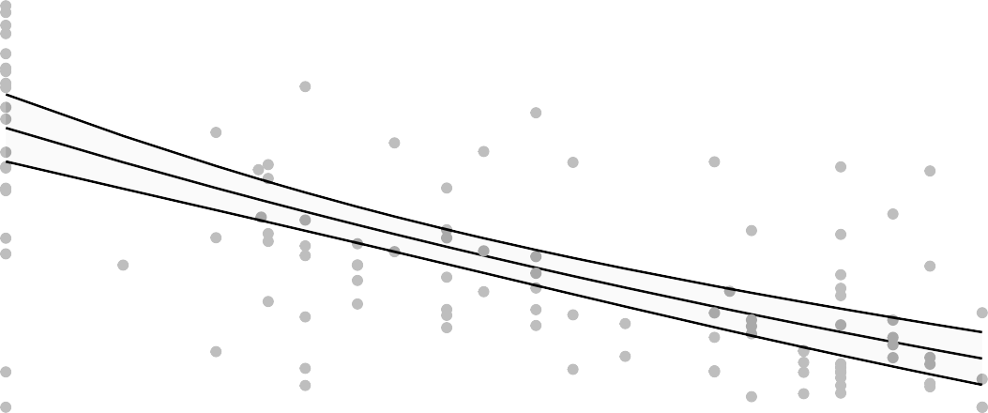
Est. = 0.86 (0.83, 0.88), p<0.001

50

40
AUC BAL N1

30

20

2 3 4
log MN 2 weeks prior challenge

Figure 6.4.1

exp
Est. = 0.82 (0.79, 0.84), p<0.001

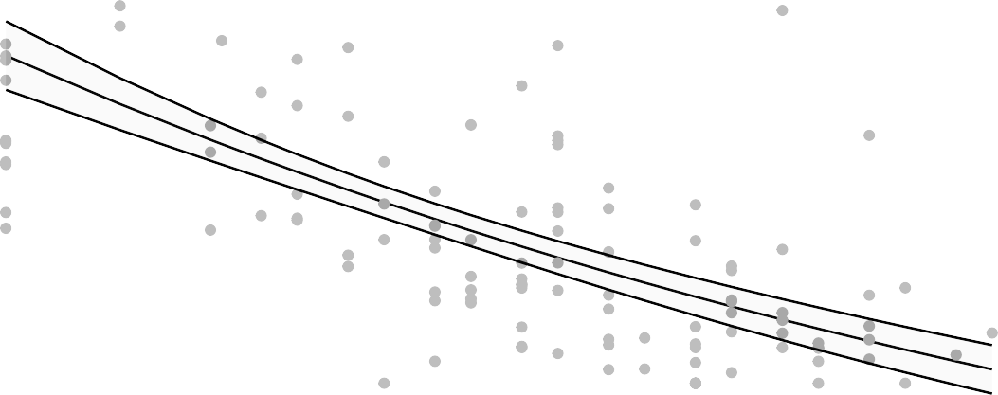
50

40
AUC BAL N1

30

20

2 3 4
log MN day challenge

lm

Figure 6.4.2

Est. = −4.83 (−5.85, −3.82), p<0.001

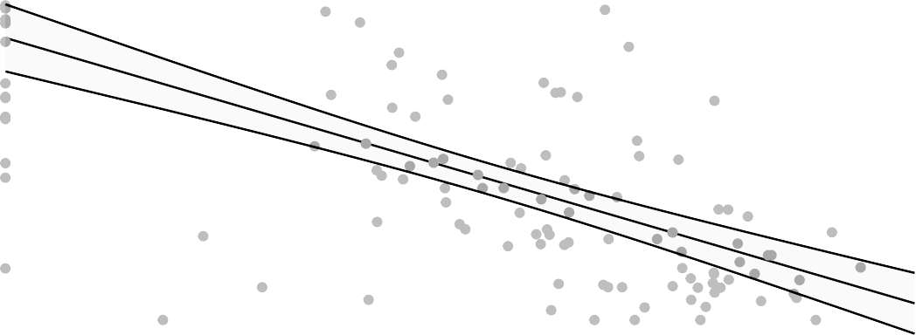
50

40
AUC BAL N1

30

20

3 4 5 6
log MSD ECL 2 weeks prior challenge

Figure 6.4.3

lm
Est. = −5.72 (−6.83, −4.61), p<0.001

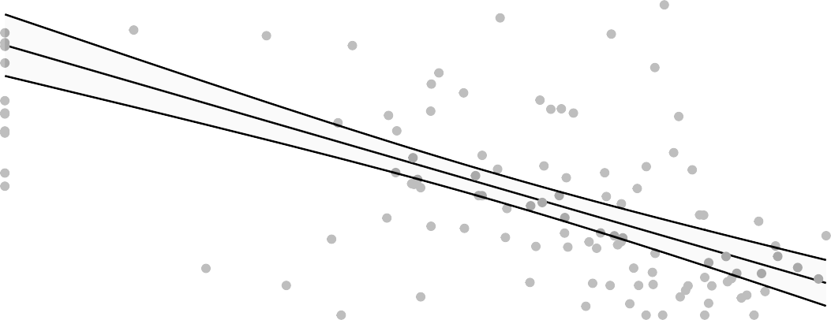
50

40
AUC BAL N1

30

20

3 4 5 6

log MSD ECL day challenge

lm
Figure 6.4.4

Est. = −5.77 (−7.29, −4.25), p<0.001

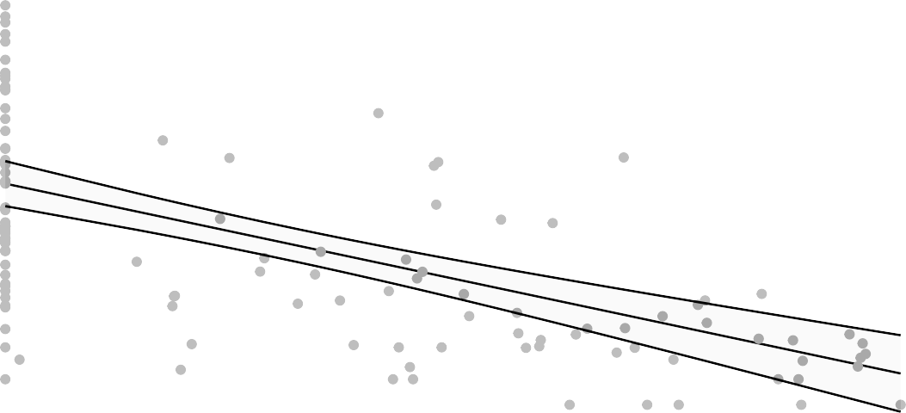
50

40
AUC BAL N1

30

20

3 4 5

log PsVNA ID50 2 weeks prior challenge
Figure 6.4.5

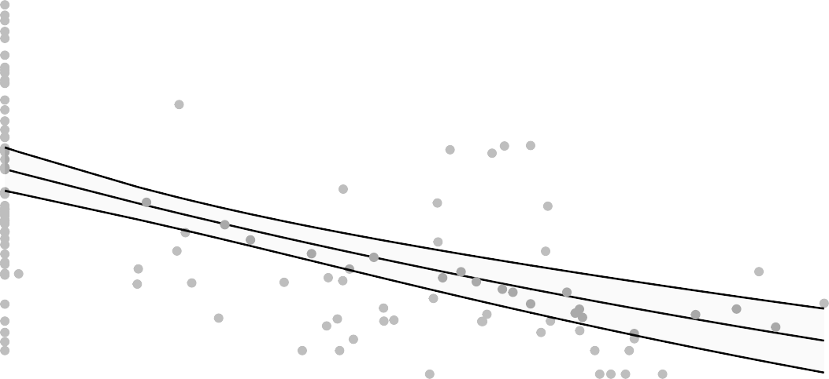
50

40
AUC BAL N1

30

20

exp
3 4
log PsVNA ID50 day challenge

Figure 6.4.6

Est. = 0.85 (0.81, 0.88), p<0.001

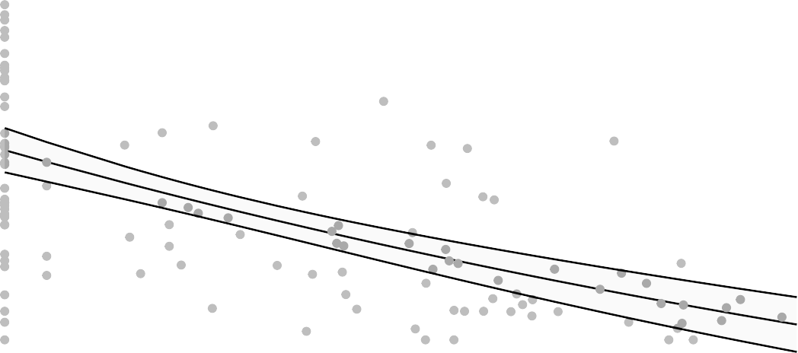
50

40
AUC BAL N1

30

20

2 3 4
log PsVNA ID80 2 weeks prior challenge

Figure 6.4.7

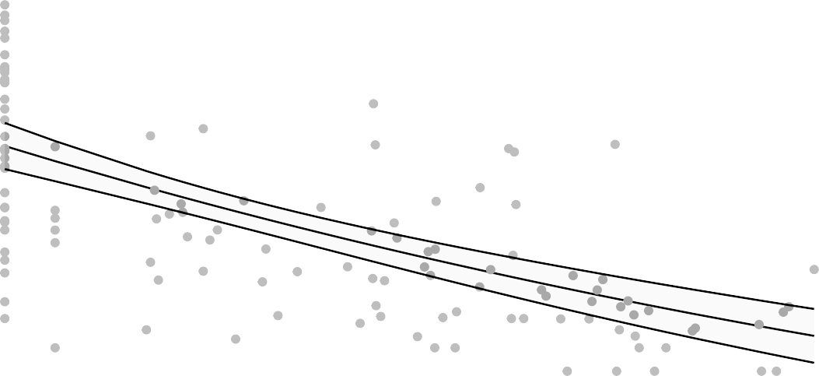
50

40
AUC BAL N1

30

20

2 3 4

exp
log PsVNA ID80 day challenge
Figure 6.4.8

Est. = 0.89 (0.87, 0.92), p<0.001

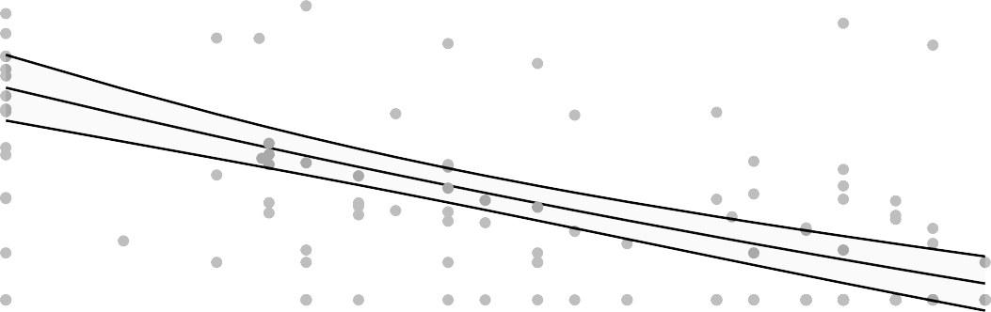
40
AUC BAL Subgenomic

30

20
2 3 4
log MN 2 weeks prior challenge

Figure 6.4.9

40

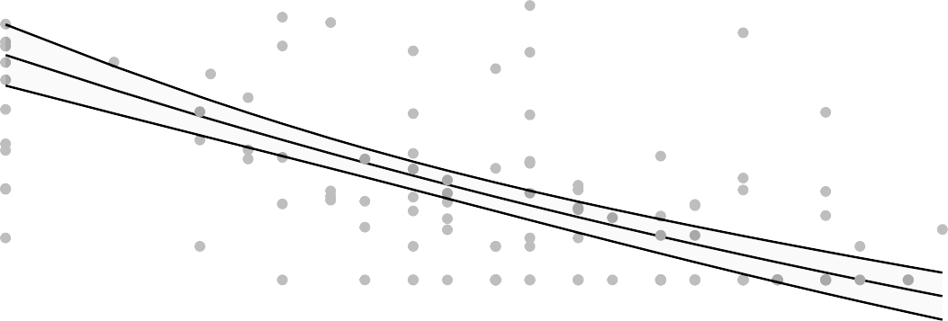
30
AUC BAL Subgenomic

20

2 3 4
log MN day challenge

lm

Figure 6.4.10

Est. = −3.05 (−3.79, −2.32), p<0.001

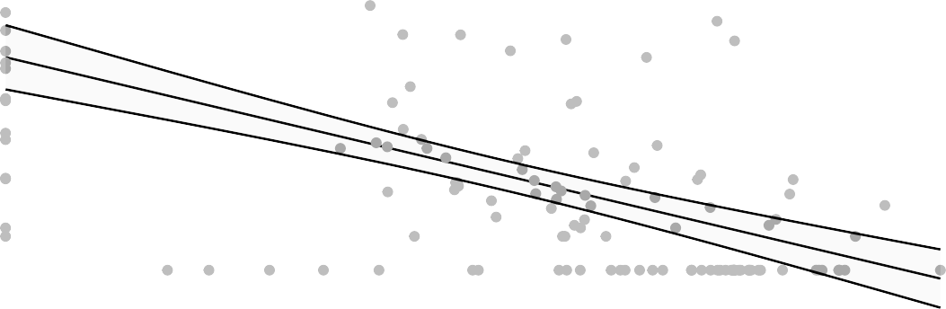
40
AUC BAL Subgenomic

30

20

3 4 5 6
log MSD ECL 2 weeks prior challenge

Figure 6.4.11

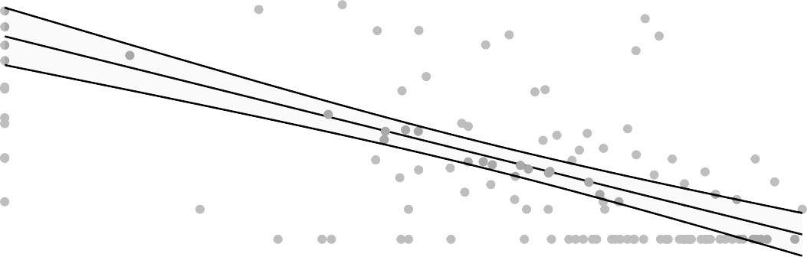
40
AUC BAL Subgenomic

30

20
3 4 5 6

log MSD ECL day challenge

lm
Figure 6.4.12

Est. = −3.3 (−4.42, −2.18), p<0.001

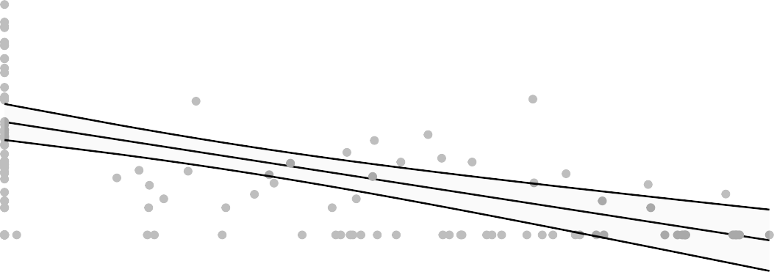
40
AUC BAL Subgenomic

30

20

3 4 5

log PsVNA ID50 2 weeks prior challenge
Figure 6.4.13

40

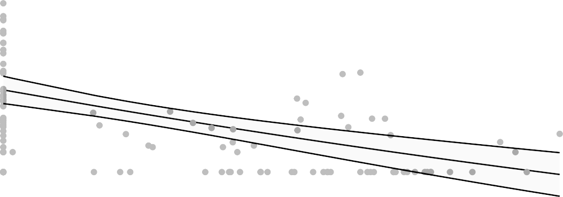
30
AUC BAL Subgenomic

20

3 4
log PsVNA ID50 day challenge

lm

Figure 6.4.14

Est. = −3.01 (−3.92, −2.1), p<0.001
AUC BAL Subgenomic

40

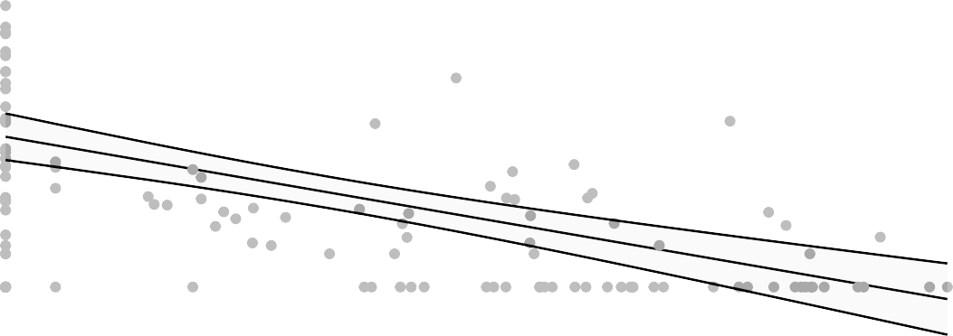
30

20

2 3 4
log PsVNA ID80 2 weeks prior challenge

Figure 6.4.15

40

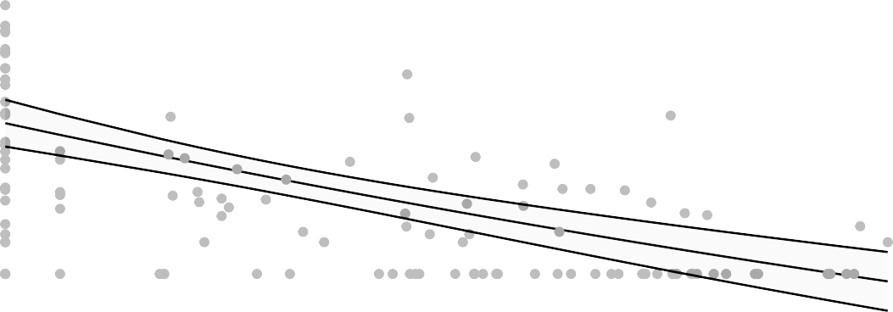
30
AUC BAL Subgenomic

20

2 3 4

log PsVNA ID80 day challenge

lm
Figure 6.4.16

Est. = −7.2 (−8.53, −5.87), p<0.001

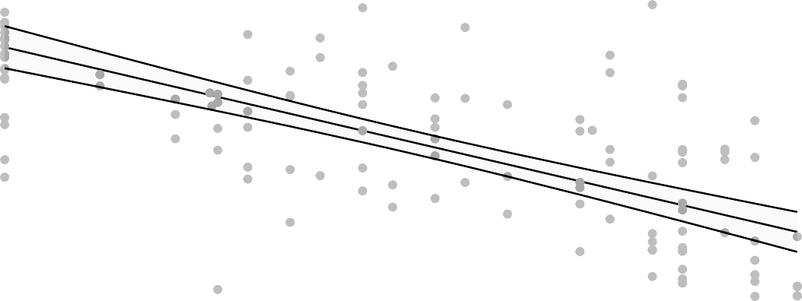
80

70
AUC Nasal Swab N1

60

50

40

30
2 3 4
log MN 2 weeks prior challenge

Figure 6.4.17

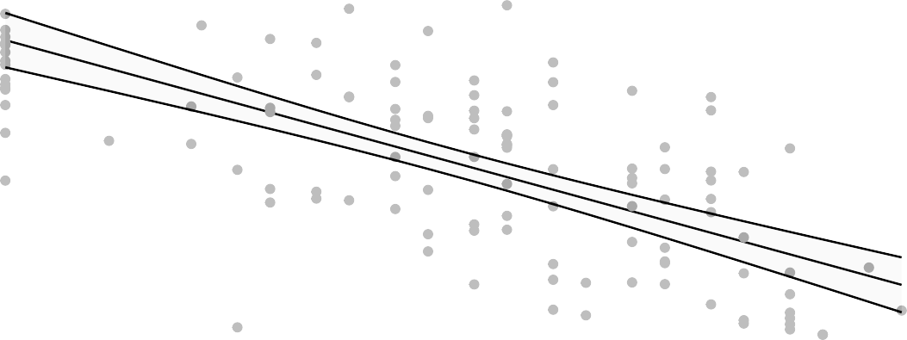
70
AUC Nasal Swab N1

60

50

40

30
2 3 4
log MN day challenge

lm

Figure 6.4.18

Est. = −6.79 (−8.09, −5.5), p<0.001

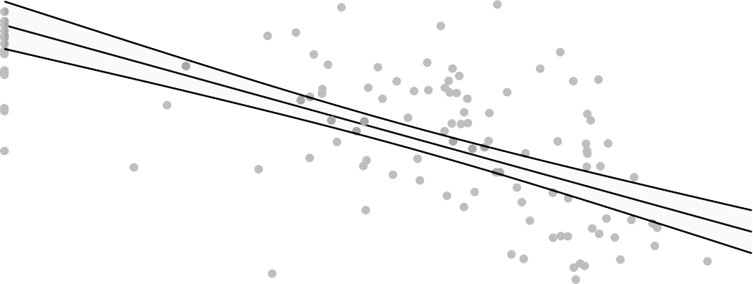
80

70
AUC Nasal Swab N1

60

50

40

30
3 4 5 6
log MSD ECL 2 weeks prior challenge

Figure 6.4.19

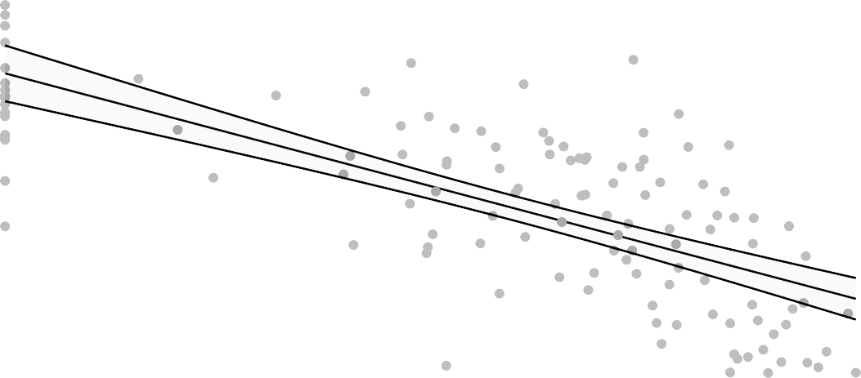
70
AUC Nasal Swab N1

60

50

40

30
3 4 5 6

log MSD ECL day challenge

lm
Figure 6.4.20

Est. = −9.02 (−10.86, −7.18), p<0.001

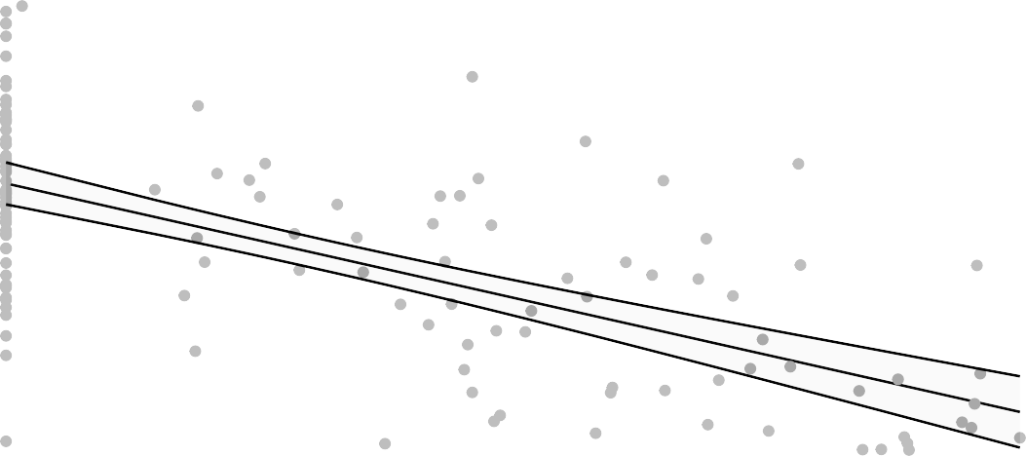
80

70
AUC Nasal Swab N1

60

50

40

30
3 4 5

log PsVNA ID50 2 weeks prior challenge
Figure 6.4.21

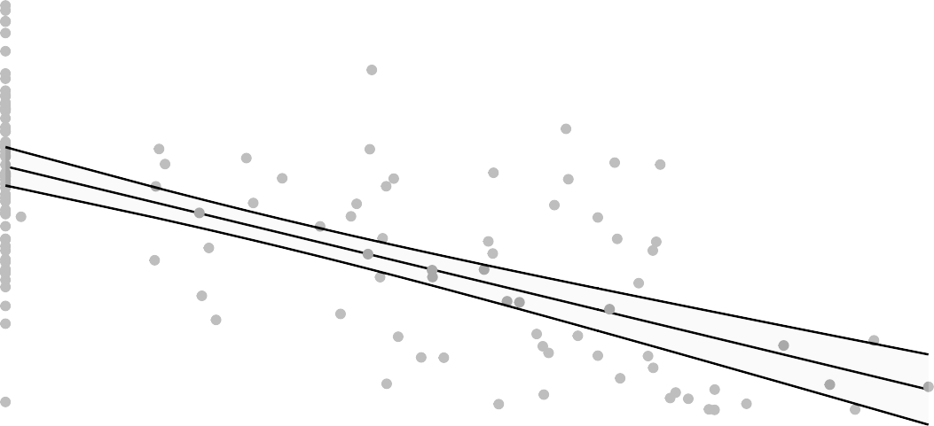
70
AUC Nasal Swab N1

60

50

40

30
3 4
log PsVNA ID50 day challenge

lm

Figure 6.4.22

Est. = −7.77 (−9.28, −6.26), p<0.001

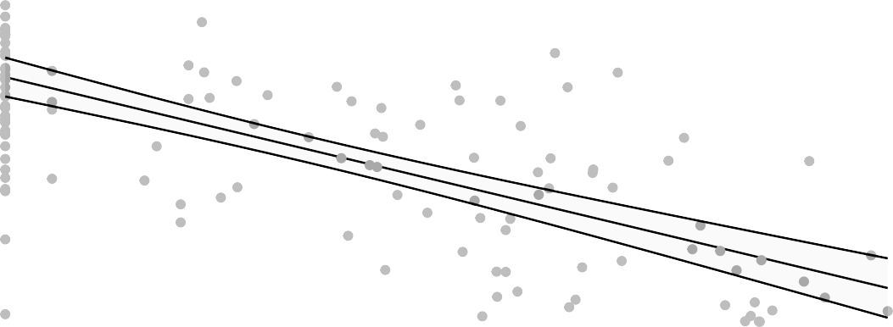
80

70
AUC Nasal Swab N1

60

50

40

30
2 3 4
log PsVNA ID80 2 weeks prior challenge

Figure 6.4.23

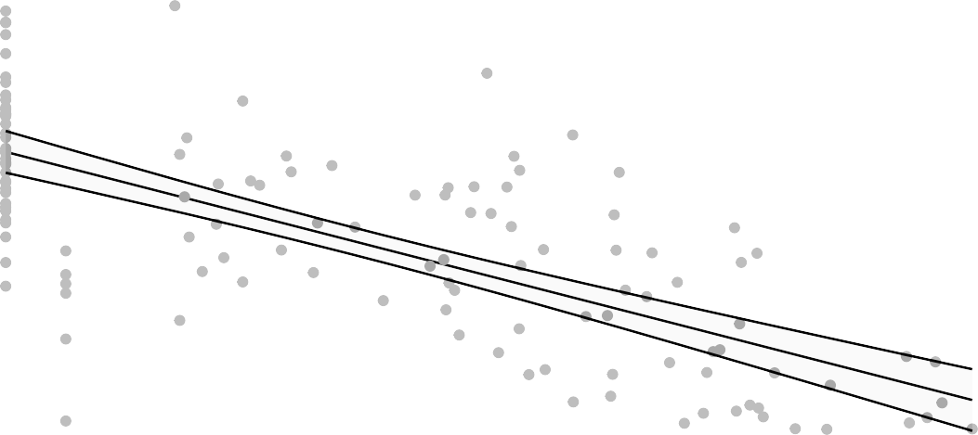
70
AUC Nasal Swab N1

60

50

40

30
2 3 4

log PsVNA ID80 day challenge

lm
Figure 6.4.24

Est. = −3.68 (−4.33, −3.03), p<0.001

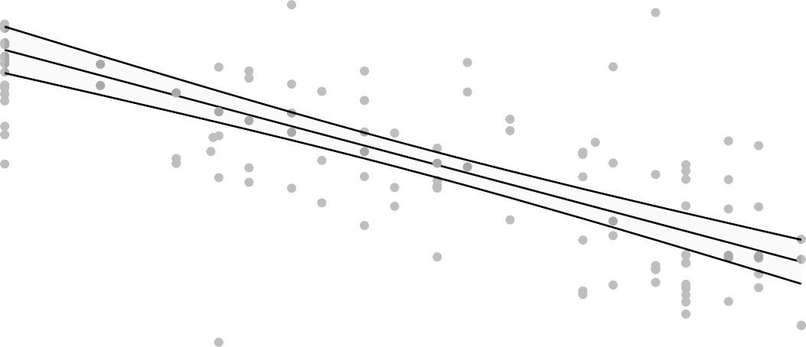
55

50
AUC Nasal Swab Subgenomic

45

40

35

2 3 4
log MN 2 weeks prior challenge

Figure 6.4.25

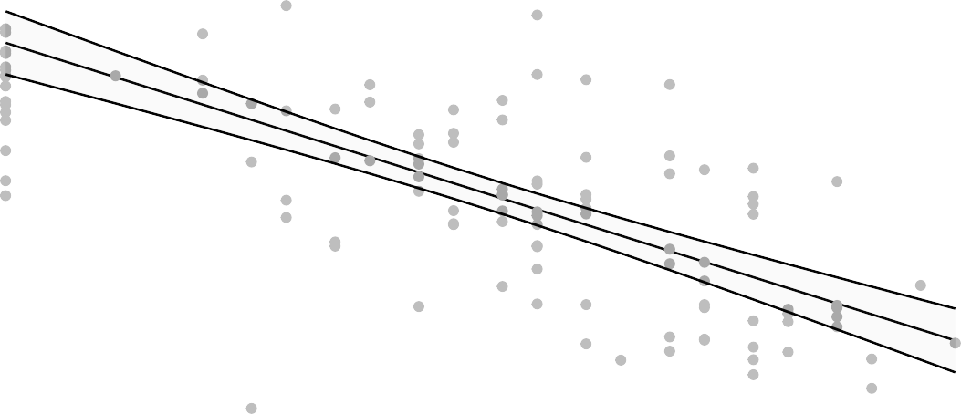
50
AUC Nasal Swab Subgenomic

45

40

35

2 3 4
log MN day challenge

lm

Figure 6.4.26

Est. = −3.32 (−3.98, −2.66), p<0.001

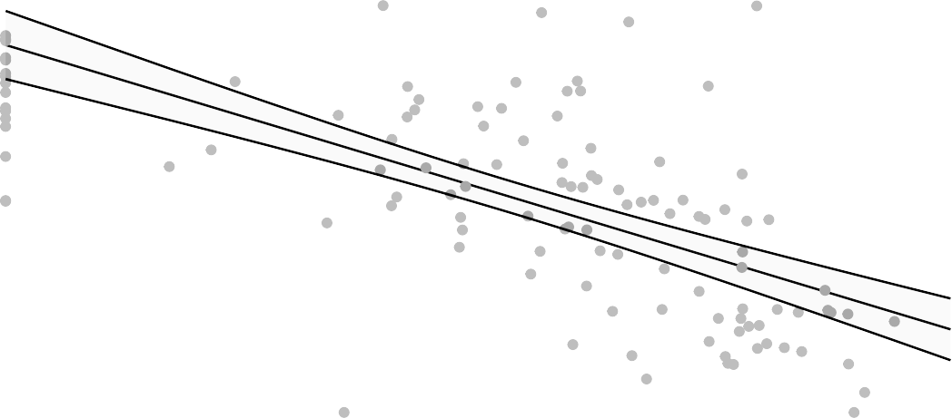
55

50
AUC Nasal Swab Subgenomic

45

40

35

3 4 5 6
log MSD ECL 2 weeks prior challenge

Figure 6.4.27

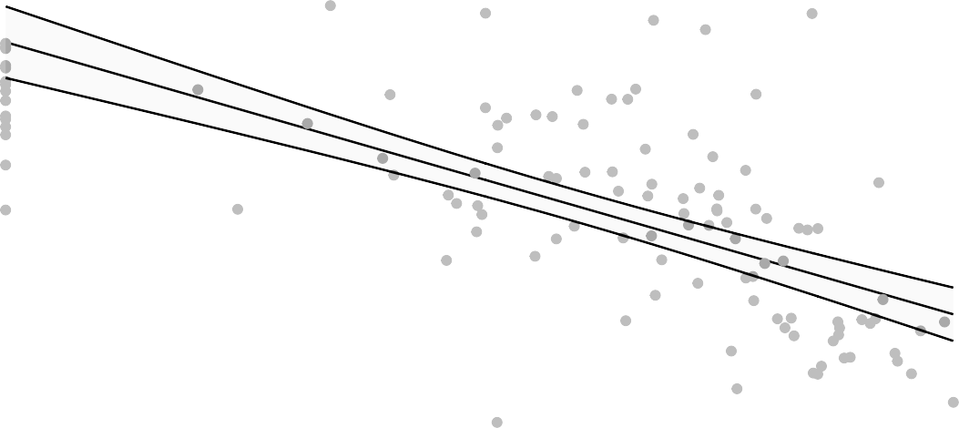
50
AUC Nasal Swab Subgenomic

45

40

35

3 4 5 6

exp
log MSD ECL day challenge
Figure 6.4.28

Est. = 0.9 (0.88, 0.92), p<0.001

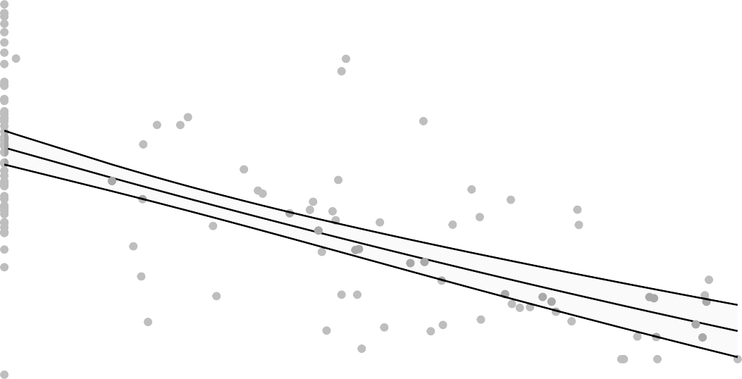
55

50
AUC Nasal Swab Subgenomic

45

40

35

3 4 5

log PsVNA ID50 2 weeks prior challenge
Figure 6.4.29

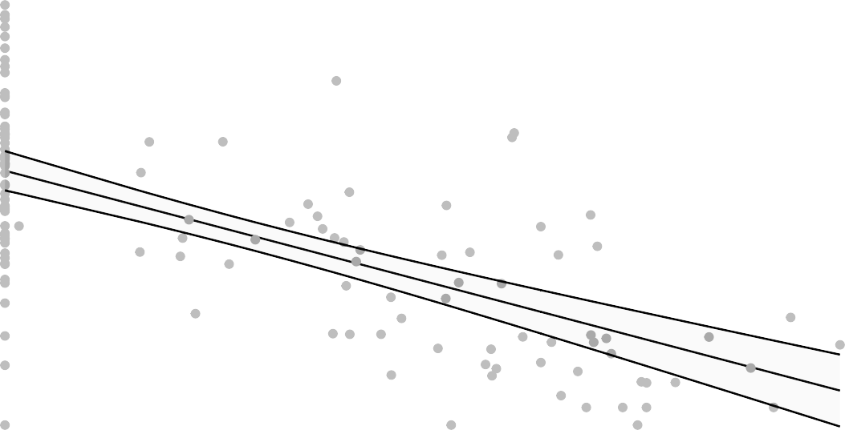
50
AUC Nasal Swab Subgenomic

45

40

35

3 4
log PsVNA ID50 day challenge

lm

Figure 6.4.30

Est. = −4 (−4.73, −3.26), p<0.001

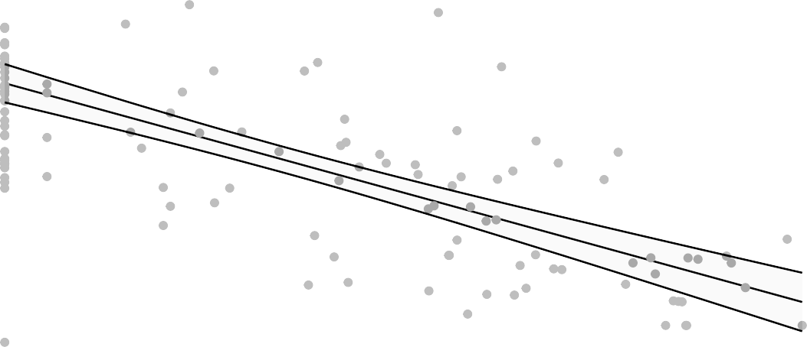
55

50
AUC Nasal Swab Subgenomic

45

40

35

2 3 4
log PsVNA ID80 2 weeks prior challenge

Figure 6.4.31

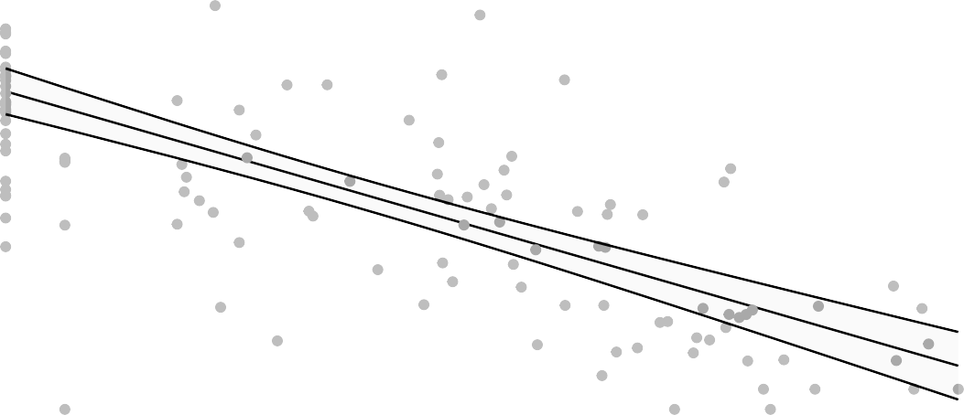
50
AUC Nasal Swab Subgenomic

45

40

35

2 3 4

log PsVNA ID80 day challenge

lm
Figure 6.4.32

Est. = −4.15 (−5.19, −3.11), p<0.001

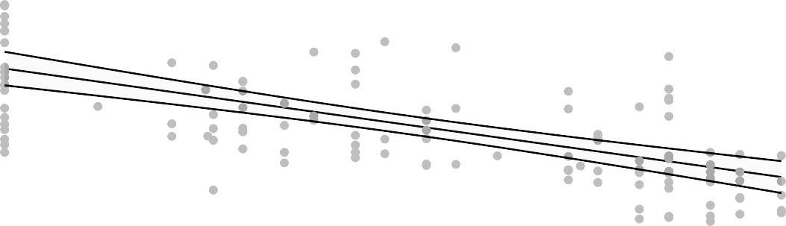
80

70

60
AUC OP Swab N1

50

40

30
2 3 4
log MN 2 weeks prior challenge

Figure 6.4.33

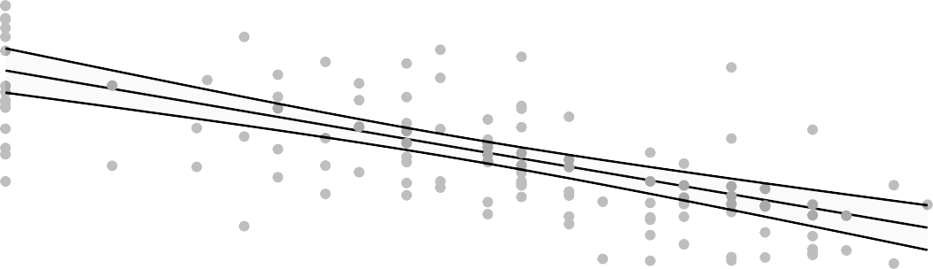
70

60
AUC OP Swab N1

50

40

30
2 3 4
log MN day challenge

lm

Figure 6.4.34

Est. = −4.1 (−5.08, −3.11), p<0.001

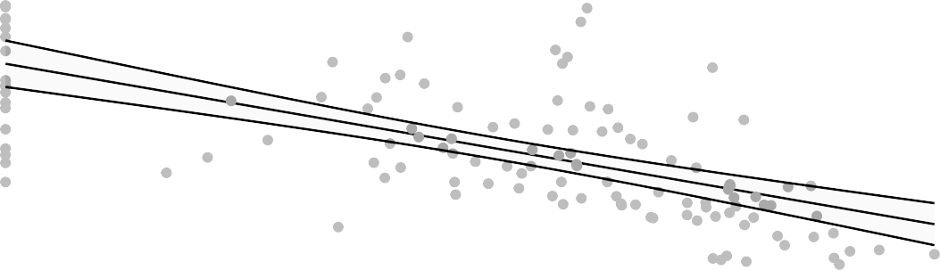
80

70

60
AUC OP Swab N1

50

40

30
3 4 5 6
log MSD ECL 2 weeks prior challenge

Figure 6.4.35

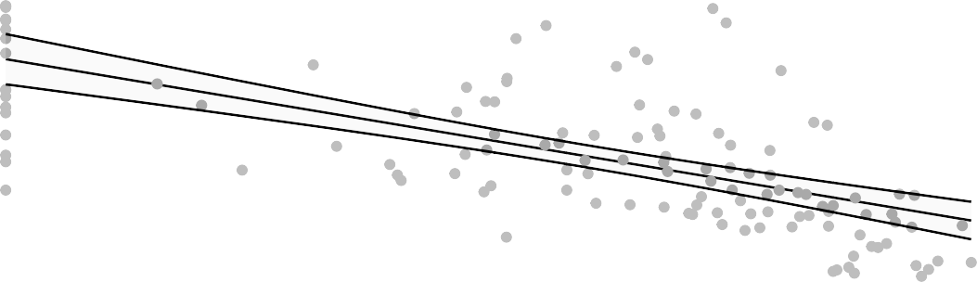
70

60
AUC OP Swab N1

50

40

30
3 4 5 6

log MSD ECL day challenge

lm
Figure 6.4.36

Est. = −5.43 (−6.81, −4.04), p<0.001

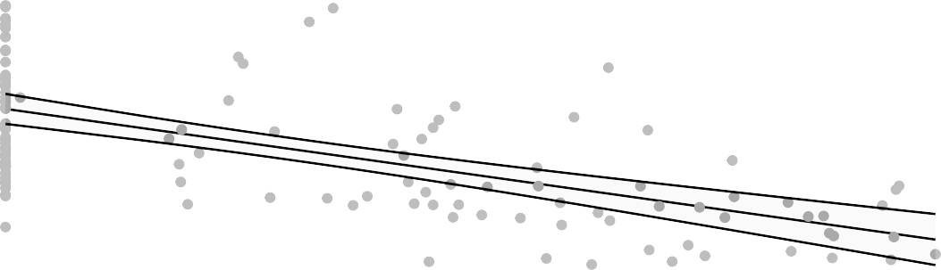
80

70

60
AUC OP Swab N1

50

40

30
3 4 5

log PsVNA ID50 2 weeks prior challenge
Figure 6.4.37

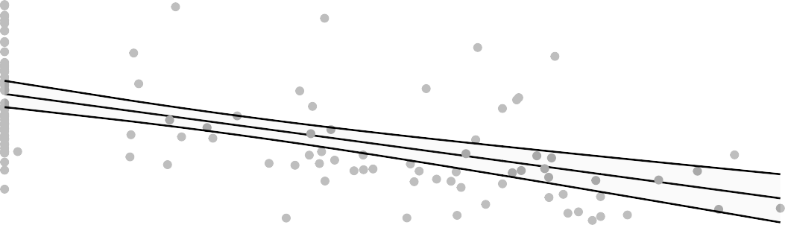
70

60
AUC OP Swab N1

50

40

30
3 4
log PsVNA ID50 day challenge

lm

Figure 6.4.38

Est. = −4.62 (−5.77, −3.46), p<0.001

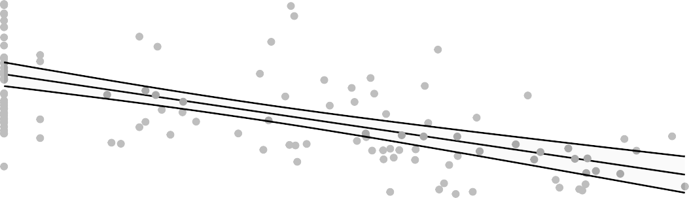
80

70

60
AUC OP Swab N1

50

40

30
2 3 4
log PsVNA ID80 2 weeks prior challenge

Figure 6.4.39

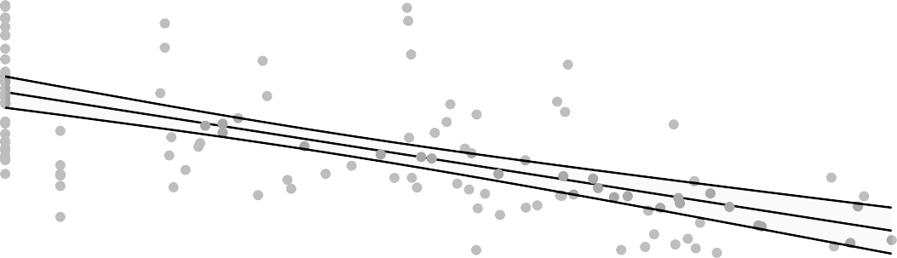
70

60
AUC OP Swab N1

50

40

30
2 3 4

log PsVNA ID80 day challenge

lm
Figure 6.4.40

Est. = −2.08 (−2.73, −1.43), p<0.001

60
AUC OP Swab Subgenomic

50

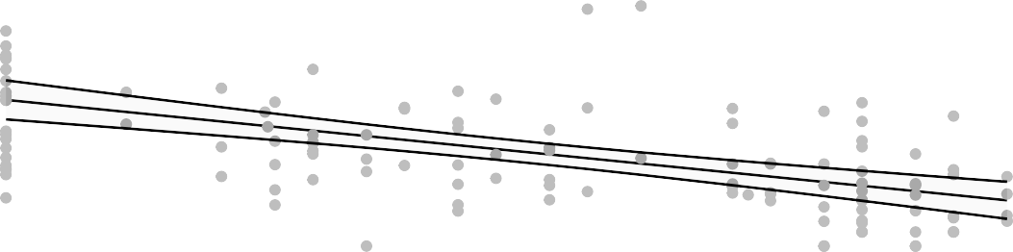
40

2 3 4
log MN 2 weeks prior challenge

Figure 6.4.41

60
AUC OP Swab Subgenomic

50

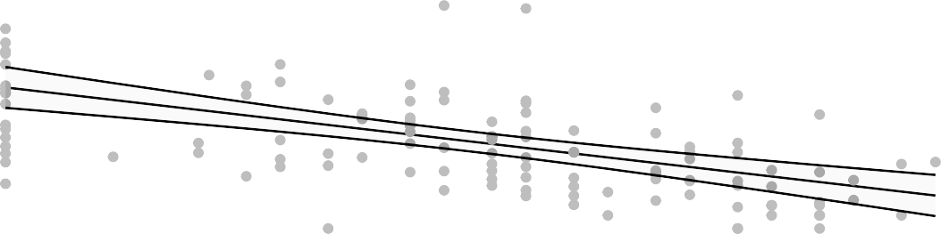
40

2 3 4
log MN day challenge

lm

Figure 6.4.42

Est. = −2 (−2.63, −1.37), p<0.001

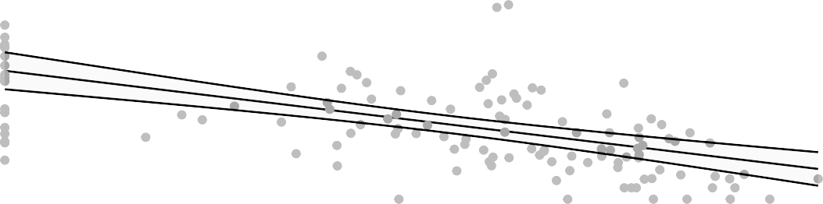
60
AUC OP Swab Subgenomic

50

40

3 4 5 6
log MSD ECL 2 weeks prior challenge

Figure 6.4.43

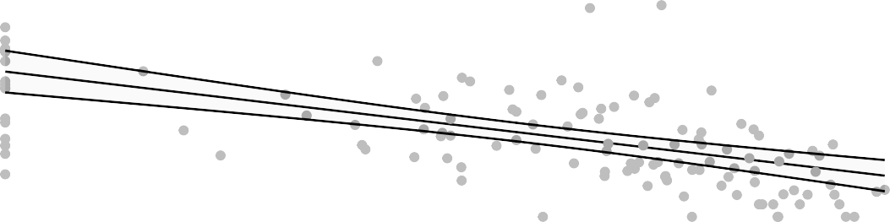
60
AUC OP Swab Subgenomic

50

40

3 4 5 6

log MSD ECL day challenge

lm
Figure 6.4.44

Est. = −2.71 (−3.58, −1.84), p<0.001

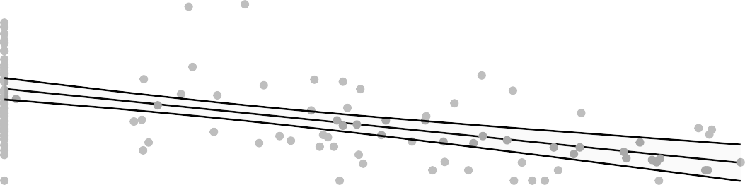
60
AUC OP Swab Subgenomic

50

40

3 4 5

log PsVNA ID50 2 weeks prior challenge
Figure 6.4.45

60
AUC OP Swab Subgenomic

50

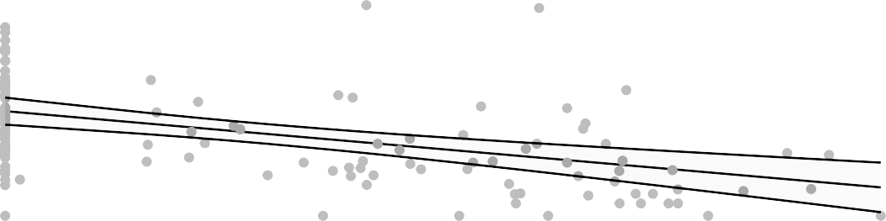
40

3 4
log PsVNA ID50 day challenge

lm

Figure 6.4.46

Est. = −2.29 (−3.02, −1.56), p<0.001

60
AUC OP Swab Subgenomic

50

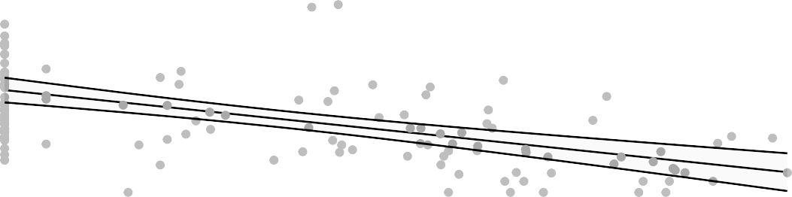
40

2 3 4
log PsVNA ID80 2 weeks prior challenge

Figure 6.4.47

60
AUC OP Swab Subgenomic

50

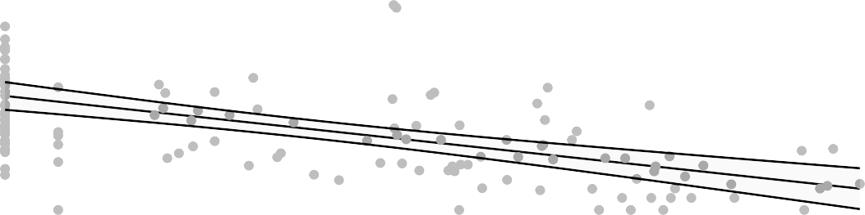
40

2 3 4

log PsVNA ID80 day challenge

lm
Figure 6.4.48

Est. = −0.66 (−0.86, −0.45), p<0.001

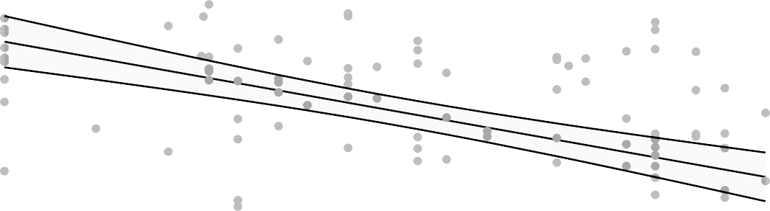
8
log VL Day2 PostChallenge BAL N1

6

4

2
2 3 4
log MN 2 weeks prior challenge

Figure 6.4.49

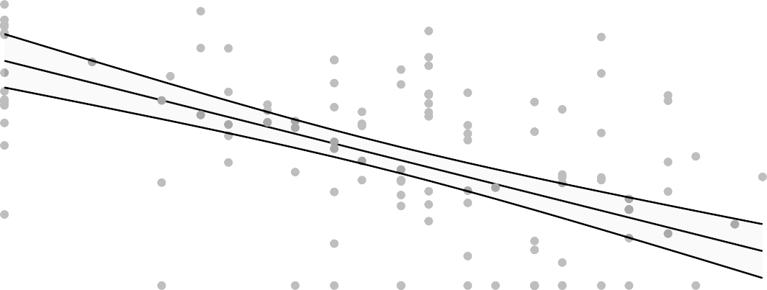
6
log VL Day2 PostChallenge BAL N1

4

2
2 3 4
log MN day challenge

lm

Figure 6.4.50

Est. = −0.61 (−0.81, −0.42), p<0.001

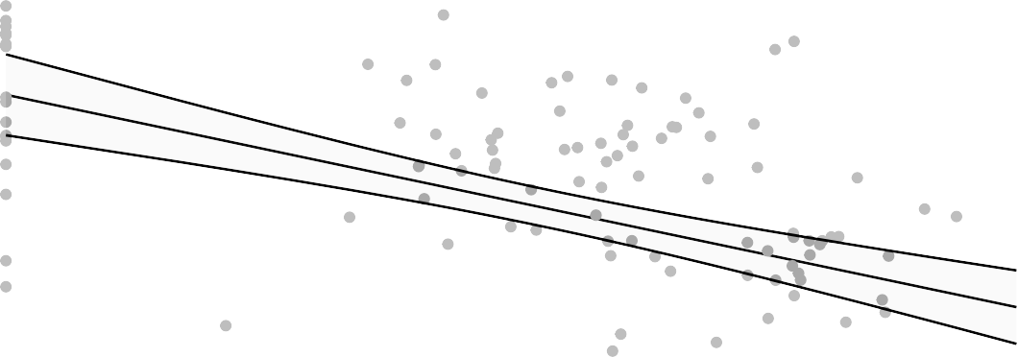
8

6
log VL Day2 PostChallenge BAL N1

4

2
3 4 5 6
log MSD ECL 2 weeks prior challenge

Figure 6.4.51

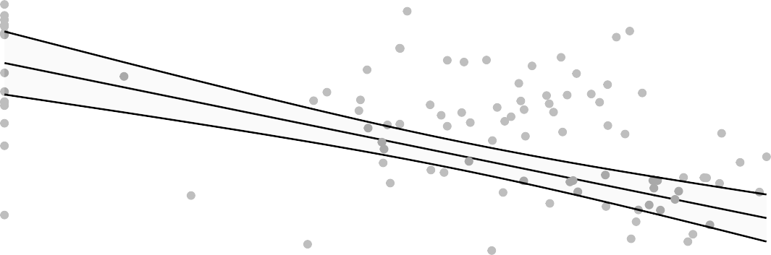
6
log VL Day2 PostChallenge BAL N1

4

2
3 4 5 6

log MSD ECL day challenge

lm
Figure 6.4.52

Est. = −0.9 (−1.16, −0.64), p<0.001

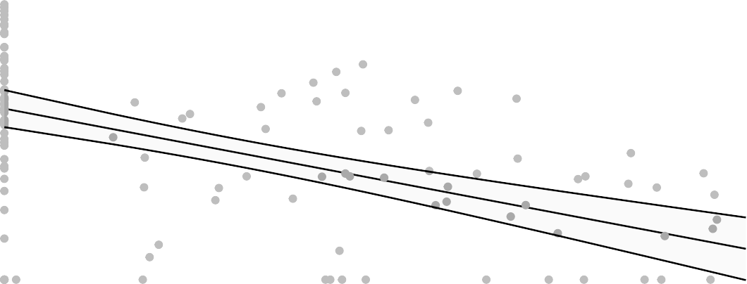
8

6
log VL Day2 PostChallenge BAL N1

4

2
3 4 5

log PsVNA ID50 2 weeks prior challenge
Figure 6.4.53

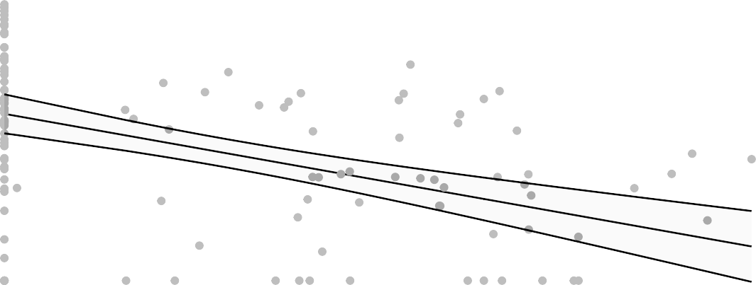
6
log VL Day2 PostChallenge BAL N1

4

2
3 4
log PsVNA ID50 day challenge

lm

Figure 6.4.54

Est. = −0.75 (−0.97, −0.52), p<0.001

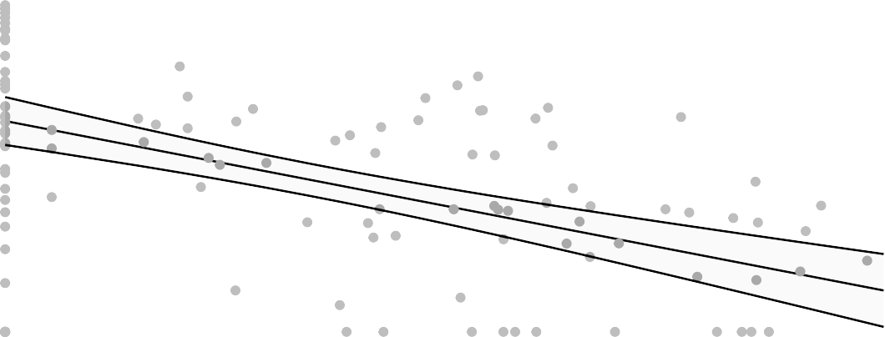
8
log VL Day2 PostChallenge BAL N1

6

4

2
2 3 4
log PsVNA ID80 2 weeks prior challenge

Figure 6.4.55

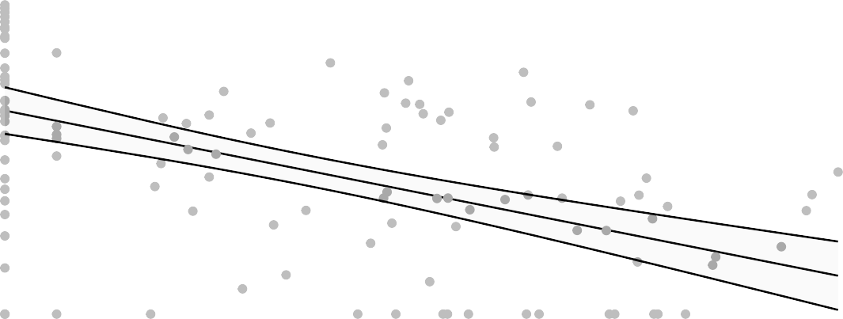
6
log VL Day2 PostChallenge BAL N1

4

2
2 3 4

log PsVNA ID80 day challenge

lm
Figure 6.4.56

Est. = −0.69 (−0.89, −0.49), p<0.001

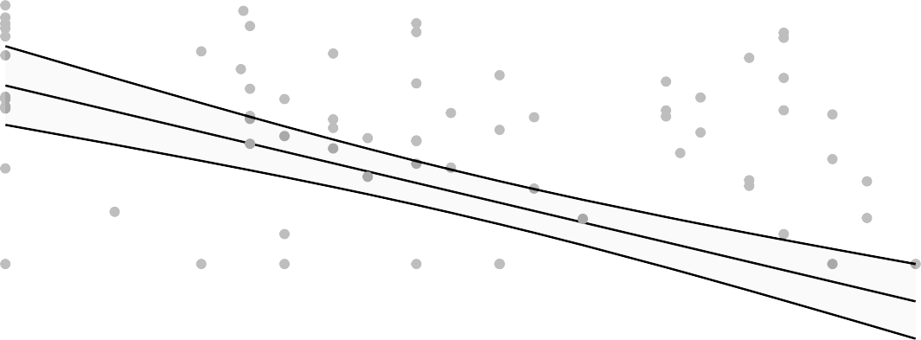
7
log VL Day2 PostChallenge BAL Subgenomic

6

5

4

3

2 3 4
log MN 2 weeks prior challenge

Figure 6.4.57

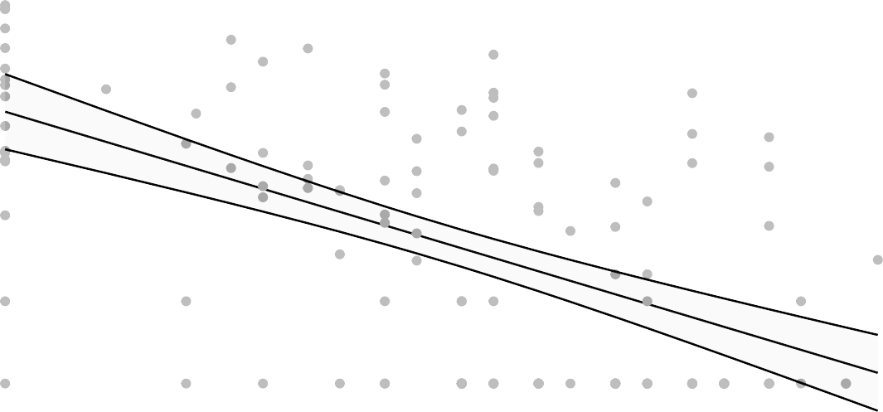
6
log VL Day2 PostChallenge BAL Subgenomic

5

4

3

2
2 3 4
log MN day challenge

lm

Figure 6.4.58

Est. = −0.64 (−0.84, −0.44), p<0.001

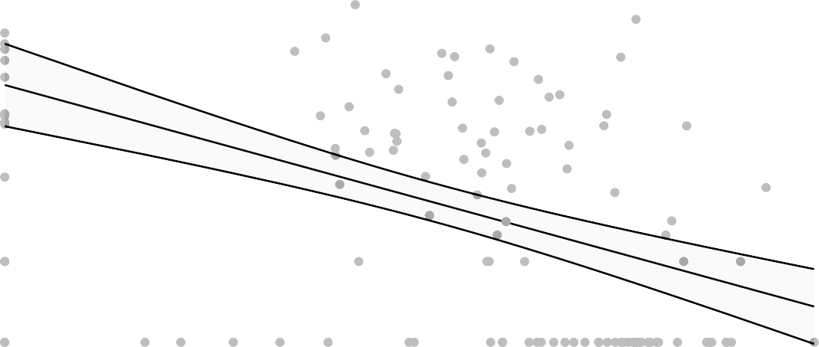
7
log VL Day2 PostChallenge BAL Subgenomic

6

5

4

3

3 4 5 6
log MSD ECL 2 weeks prior challenge

Figure 6.4.59

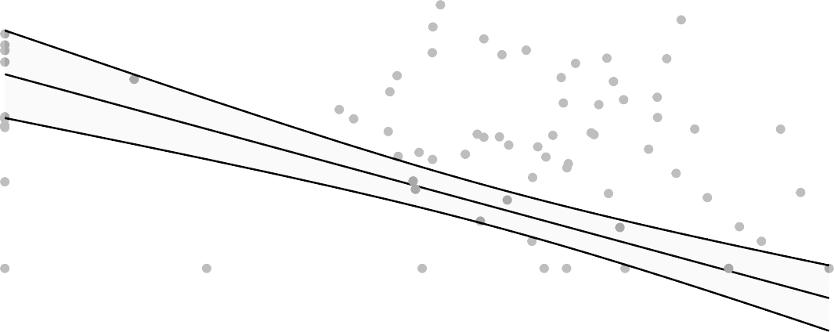
6
log VL Day2 PostChallenge BAL Subgenomic

5

4

3

3 4 5 6

exp
log MSD ECL day challenge
Figure 6.4.60

Est. = 0.78 (0.72, 0.85), p<0.001

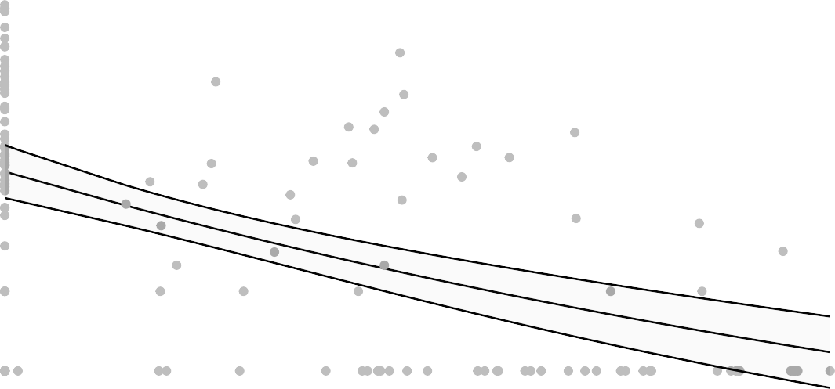
7
log VL Day2 PostChallenge BAL Subgenomic

6

5

4

3

2
3 4 5

log PsVNA ID50 2 weeks prior challenge
Figure 6.4.61

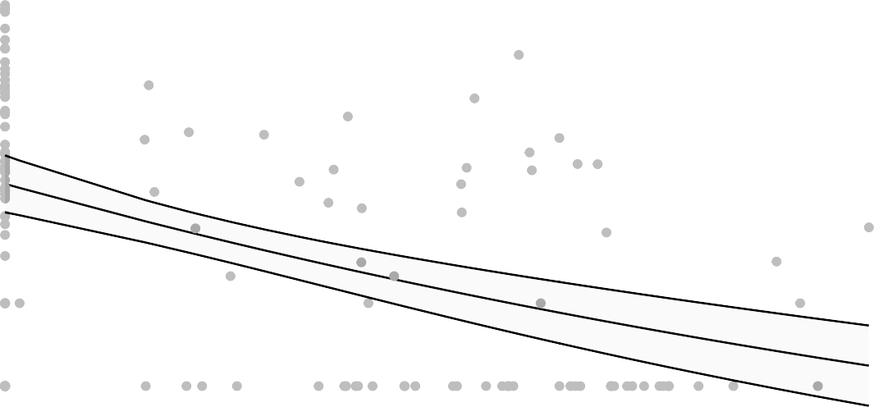
6
log VL Day2 PostChallenge BAL Subgenomic

5

4

3

2
3 4
log PsVNA ID50 day challenge
lm

Figure 6.4.62

Est. = −0.77 (−1, −0.55), p<0.001

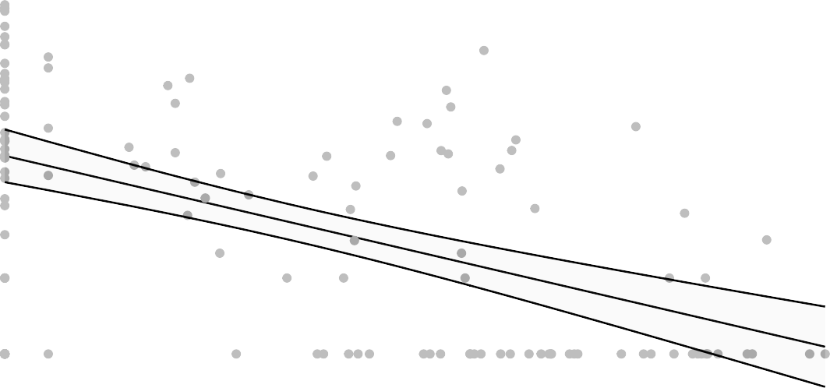
7
log VL Day2 PostChallenge BAL Subgenomic

6

5

4

3

2

2 3 4
log PsVNA ID80 2 weeks prior challenge

Figure 6.4.63

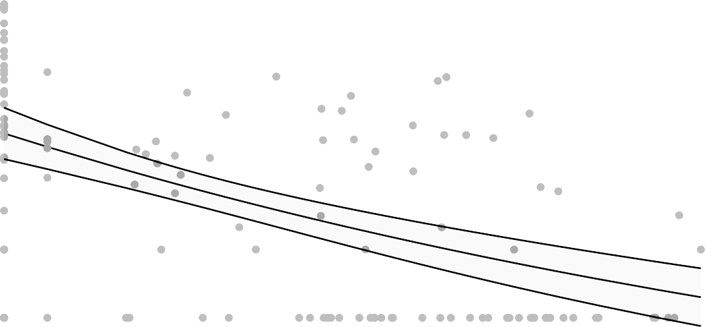
6
log VL Day2 PostChallenge BAL Subgenomic

5

4

3

2
2 3 4

log PsVNA ID80 day challenge

lm
Figure 6.4.64

Est. = −0.52 (−0.72, −0.31), p<0.001
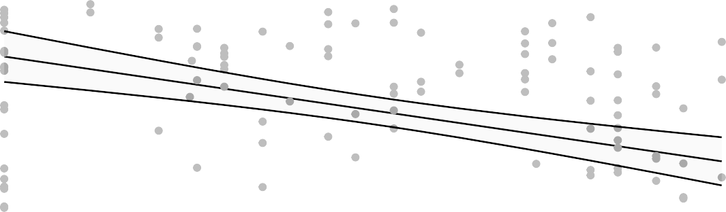
8
log VL Day2 PostChallenge OPswab N1

6

4

2
2 3 4
log MN 2 weeks prior challenge

Figure 6.4.65

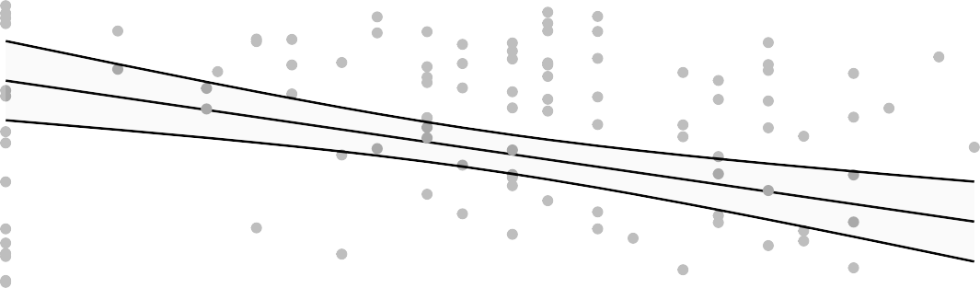
6
log VL Day2 PostChallenge OPswab N1

4

2
2 3 4
log MN day challenge

lm

Figure 6.4.66

Est. = −0.42 (−0.62, −0.22), p<0.001
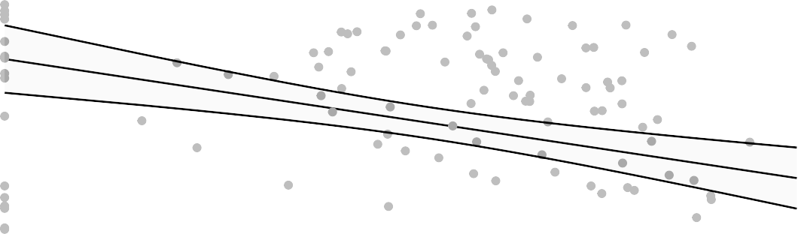
8
log VL Day2 PostChallenge OPswab N1

6

4

2
3 4 5 6
log MSD ECL 2 weeks prior challenge

Figure 6.4.67

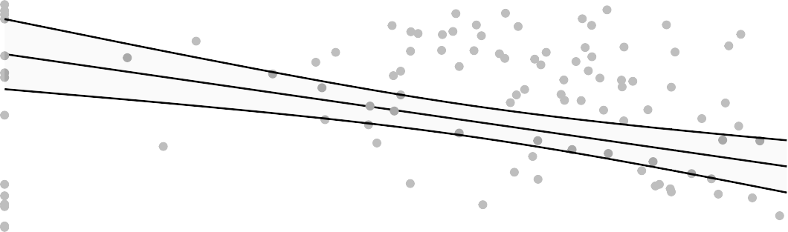
6
log VL Day2 PostChallenge OPswab N1

4

2
3 4 5 6

log MSD ECL day challenge

lm
Figure 6.4.68

Est. = −0.65 (−0.92, −0.38), p<0.001
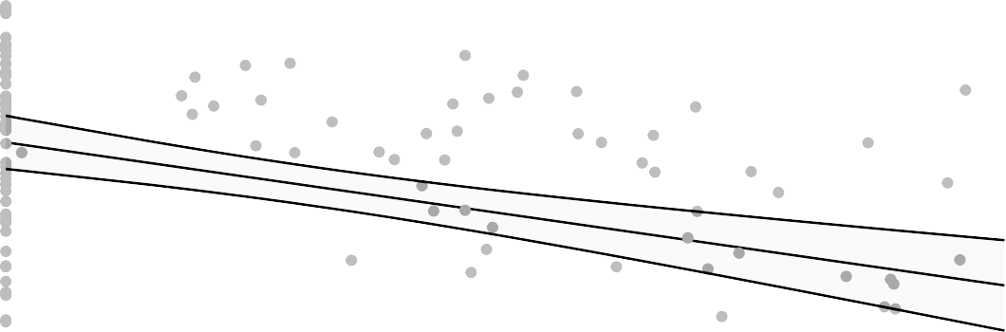
8
log VL Day2 PostChallenge OPswab N1

6

4

2
3 4 5

log PsVNA ID50 2 weeks prior challenge
Figure 6.4.69

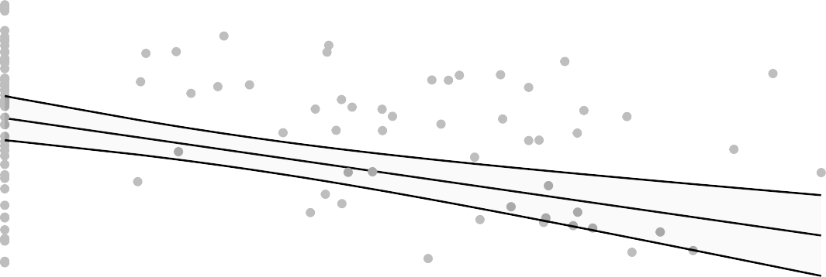
6
log VL Day2 PostChallenge OPswab N1

4

2
3 4
log PsVNA ID50 day challenge

lm

Figure 6.4.70

Est. = −0.57 (−0.79, −0.34), p<0.001
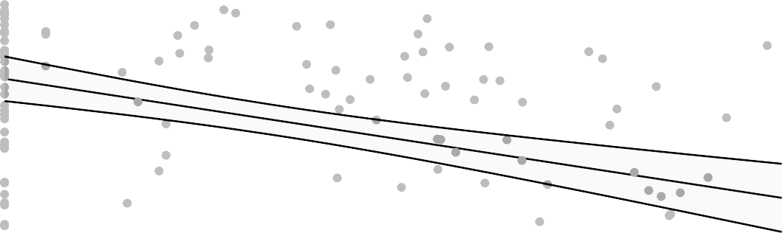
8
log VL Day2 PostChallenge OPswab N1

6

4

2
2 3 4
log PsVNA ID80 2 weeks prior challenge

Figure 6.4.71

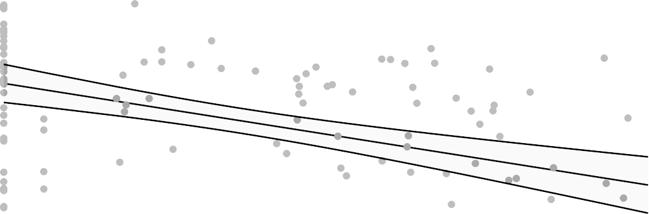
6
log VL Day2 PostChallenge OPswab N1

4

2
2 3 4

log PsVNA ID80 day challenge

lm
Figure 6.4.72

Est. = −0.52 (−0.7, −0.33), p<0.001
log VL Day2 PostChallenge OPswab Subgenomic

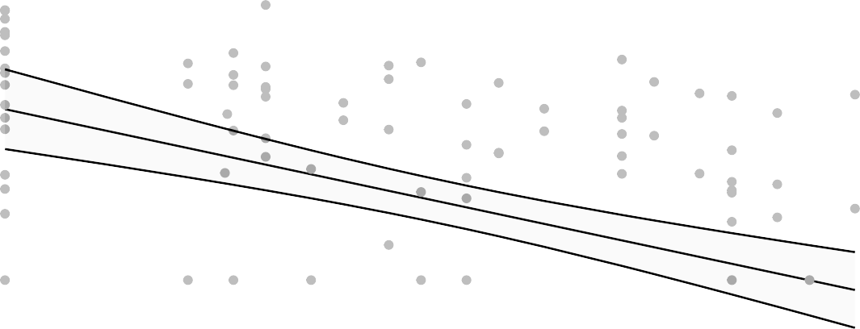
6

5

4

3

2 3 4
log MN 2 weeks prior challenge

Figure 6.4.73

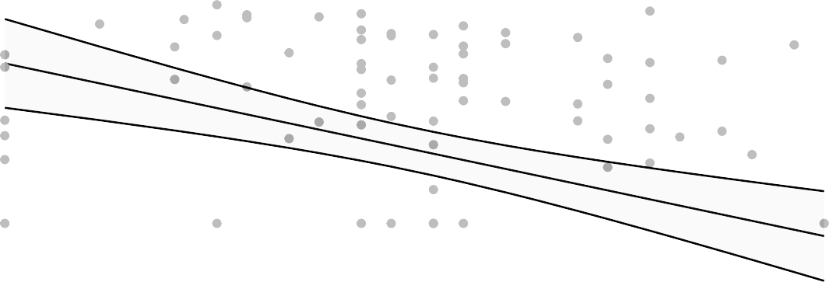
6
log VL Day2 PostChallenge OPswab Subgenomic

5

4

3

2 3 4
log MN day challenge

lm

Figure 6.4.74

Est. = −0.42 (−0.61, −0.24), p<0.001
log VL Day2 PostChallenge OPswab Subgenomic

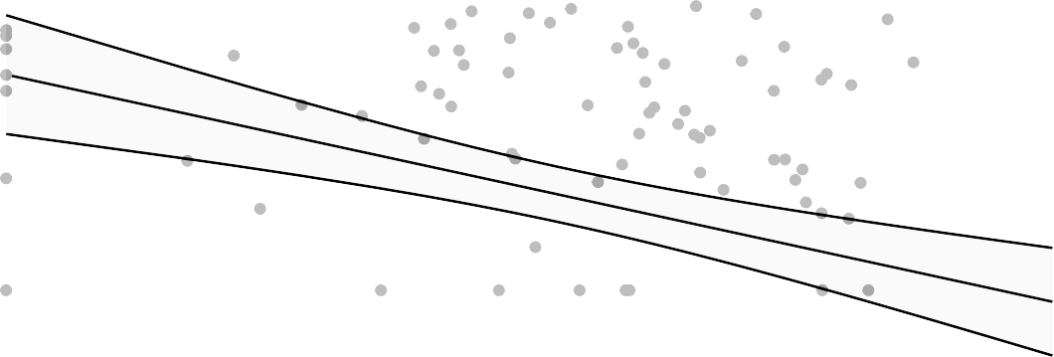
6

5

4

3

3 4 5 6
log MSD ECL 2 weeks prior challenge

Figure 6.4.75

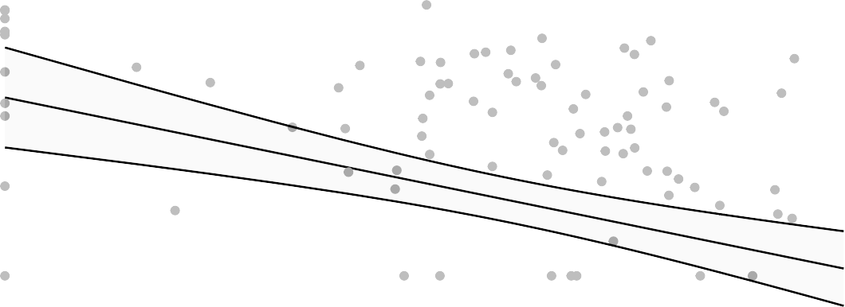
6
log VL Day2 PostChallenge OPswab Subgenomic

5

4

3

3 4 5 6

log MSD ECL day challenge

lm
Figure 6.4.76

Est. = −0.68 (−0.93, −0.44), p<0.001
log VL Day2 PostChallenge OPswab Subgenomic

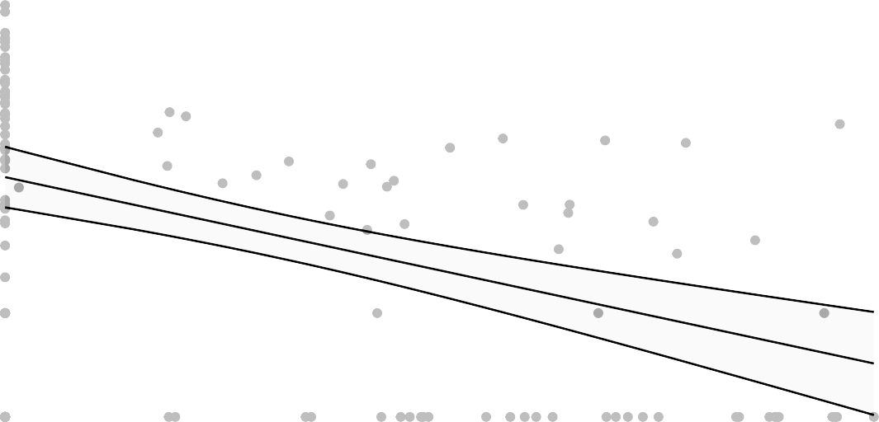
6

5

4

3

3 4 5

log PsVNA ID50 2 weeks prior challenge
Figure 6.4.77

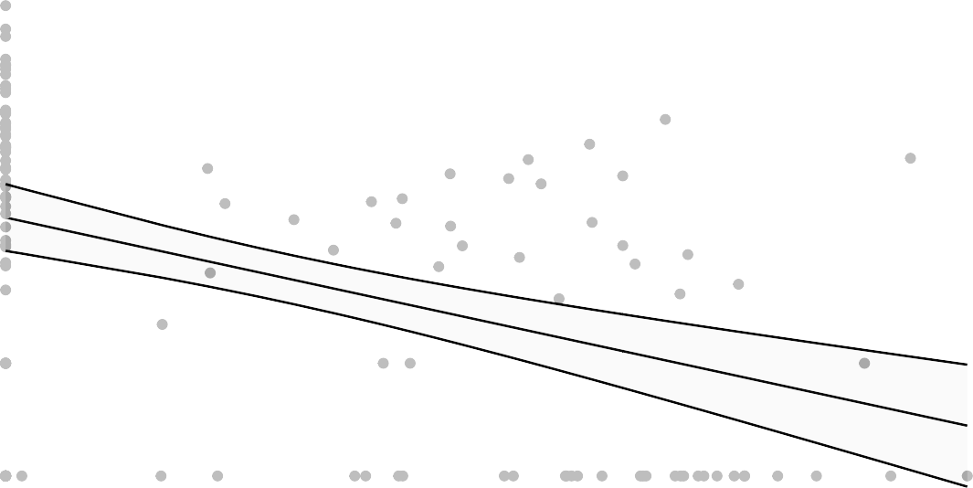
6
log VL Day2 PostChallenge OPswab Subgenomic

5

4

3

3 4
log PsVNA ID50 day challenge

lm

Figure 6.4.78

Est. = −0.59 (−0.79, −0.38), p<0.001
log VL Day2 PostChallenge OPswab Subgenomic

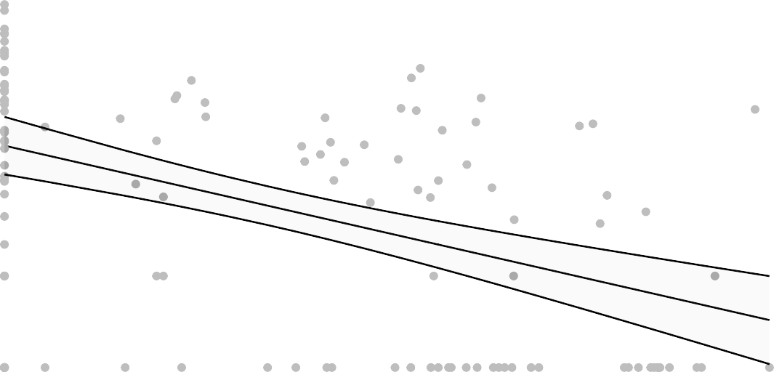
6

5

4

3

2 3 4
log PsVNA ID80 2 weeks prior challenge

Figure 6.4.79

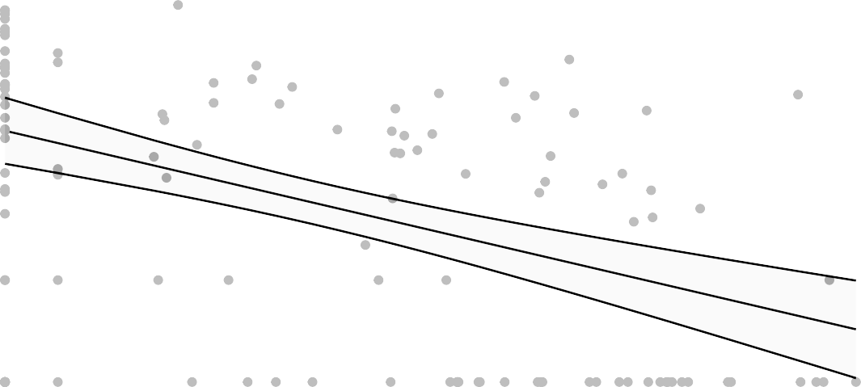
6
log VL Day2 PostChallenge OPswab Subgenomic

5

4

3

2 3 4

log PsVNA ID80 day challenge

lm
Figure 6.4.80

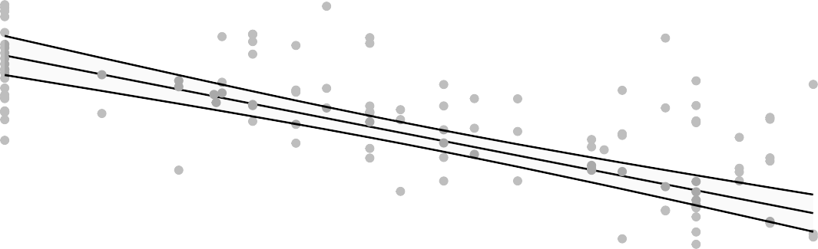
Est. = −0.78 (−0.94, −0.63), p<0.001
log VL Day2 PostChallenge NasalSwab N1

8

6

4

2
2 3 4
log MN 2 weeks prior challenge

Figure 6.4.81

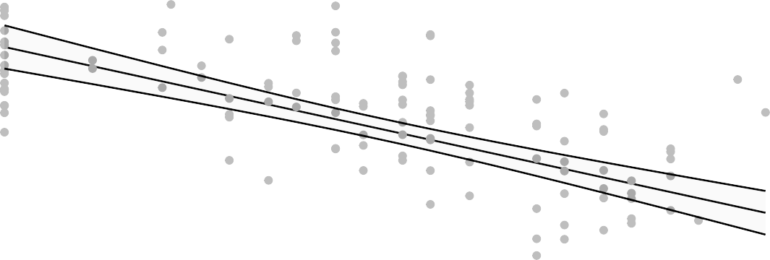
8
log VL Day2 PostChallenge NasalSwab N1

6

4

2

4pl

2 3 4
log MN day challenge

Figure 6.4.82

Est. = −0.84 (−1.03, −0.65), p<0.001

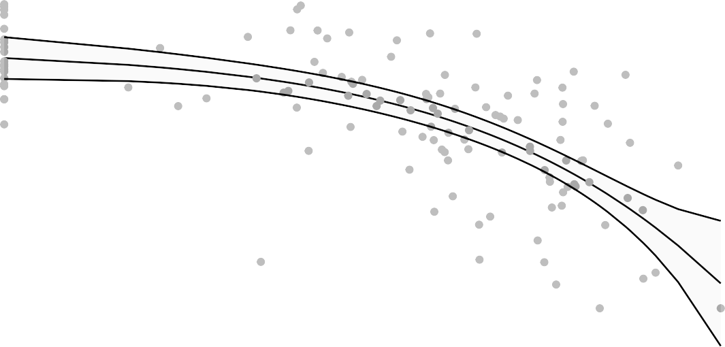
8
log VL Day2 PostChallenge NasalSwab N1

6

4

2
3 4 5 6
log MSD ECL 2 weeks prior challenge

Figure 6.4.83

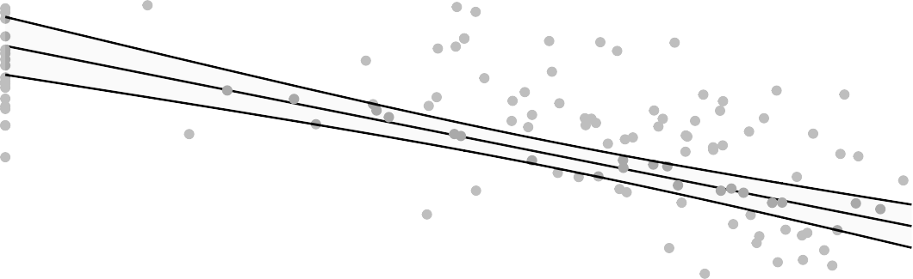
8
log VL Day2 PostChallenge NasalSwab N1

6

4

2
3 4 5 6

log MSD ECL day challenge

lm
Figure 6.4.84

Est. = −1.05 (−1.25, −0.84), p<0.001

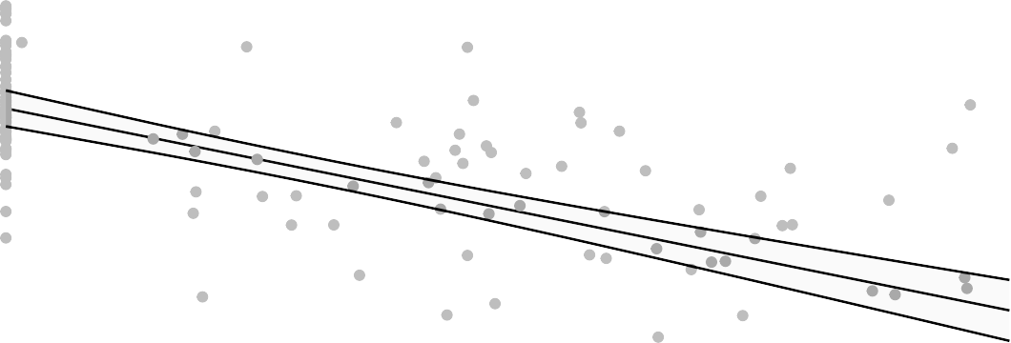
8
log VL Day2 PostChallenge NasalSwab N1

6

4

2
3 4 5

log PsVNA ID50 2 weeks prior challenge
Figure 6.4.85

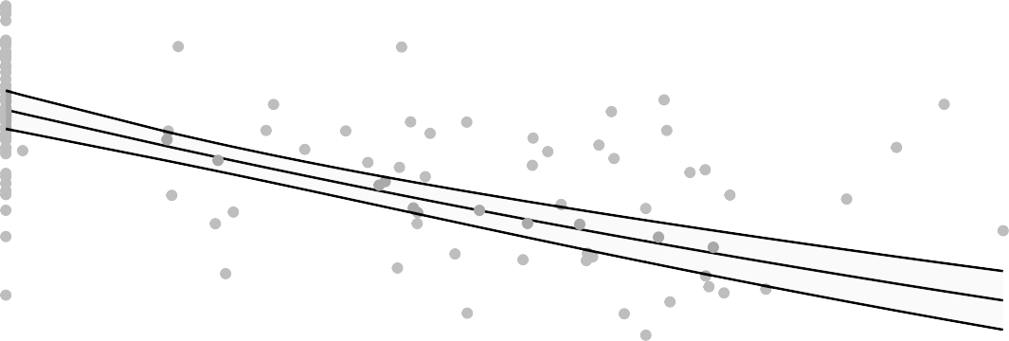
8
log VL Day2 PostChallenge NasalSwab N1

6

4

2
3 4
log PsVNA ID50 day challenge

lm

Figure 6.4.86

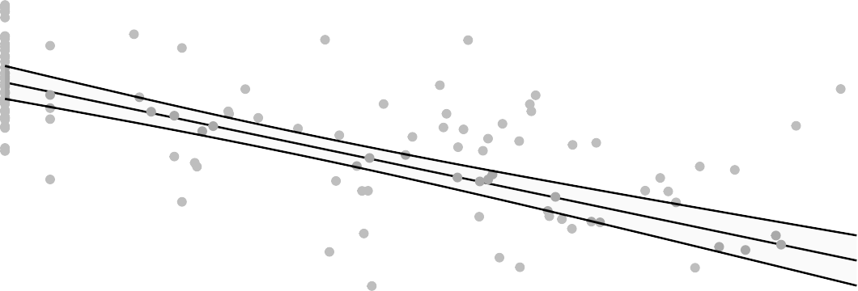
Est. = −0.88 (−1.05, −0.71), p<0.001
log VL Day2 PostChallenge NasalSwab N1

8

6

4

2
2 3 4
log PsVNA ID80 2 weeks prior challenge

Figure 6.4.87

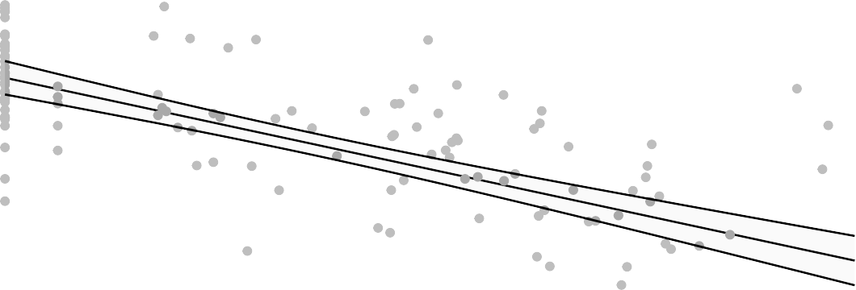
8
log VL Day2 PostChallenge NasalSwab N1

6

4

2
2 3 4

log PsVNA ID80 day challenge

lm
Figure 6.4.88

Est. = −0.93 (−1.11, −0.74), p<0.001
log VL Day2 PostChallenge NasalSwab Subgenomic

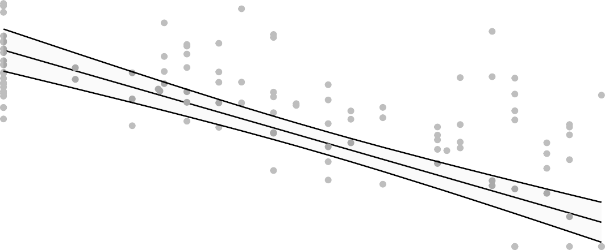
7

6

5

4

3

2 3 4
log MN 2 weeks prior challenge

Figure 6.4.89

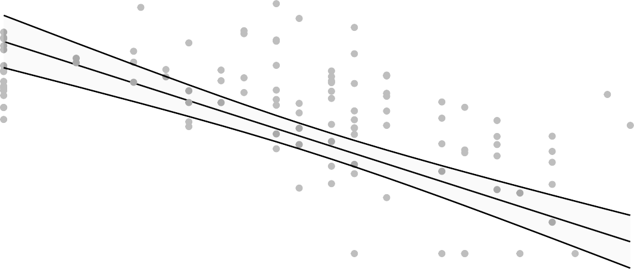
7

6

5

4

3

2 3 4
log MN day challenge

lm

Figure 6.4.90

Est. = −0.81 (−1, −0.62), p<0.001
log VL Day2 PostChallenge NasalSwab Subgenomic

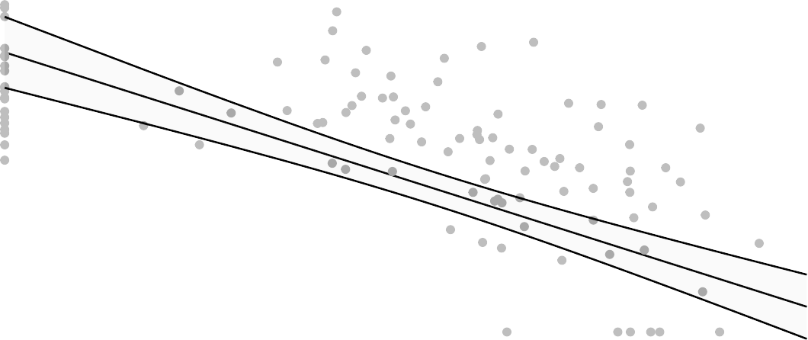
7

6

5

4

3

3 4 5 6
log VL Day2 PostChallenge NasalSwab Subgenomic
log MSD ECL 2 weeks prior challenge

Figure 6.4.91

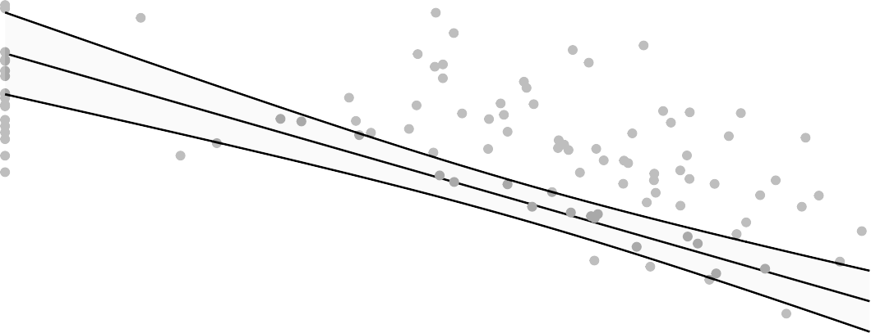
7

6

5

4

3

3 4 5 6

exp
log MSD ECL day challenge
Figure 6.4.92

Est. = 0.78 (0.74, 0.82), p<0.001
log VL Day2 PostChallenge NasalSwab Subgenomic

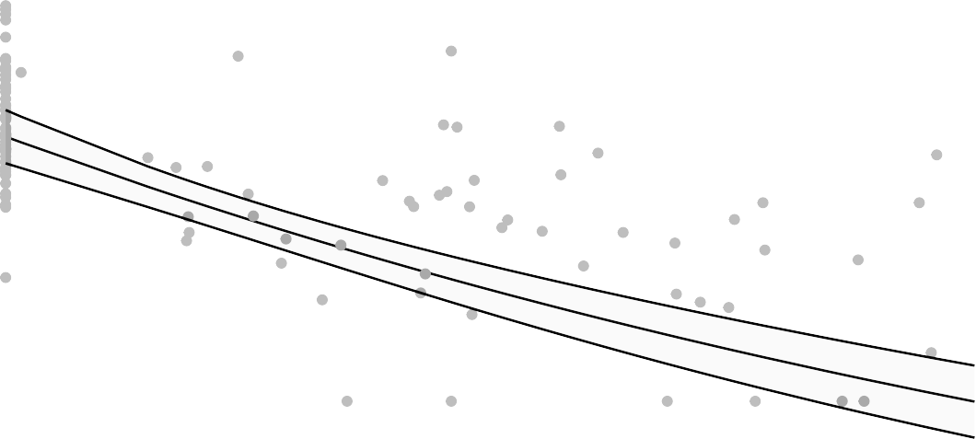
7

6

5

4

3

3 4 5

log PsVNA ID50 2 weeks prior challenge
log VL Day2 PostChallenge NasalSwab Subgenomic
Figure 6.4.93

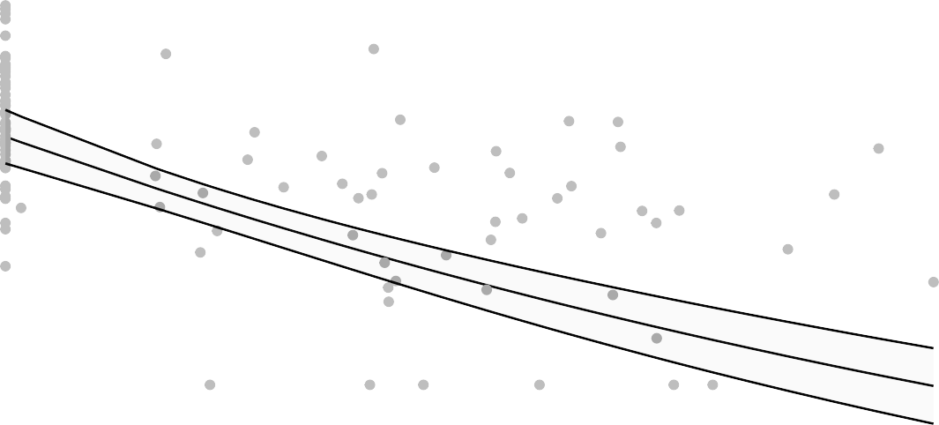
7

6

5

4

3

3 4
log PsVNA ID50 day challenge

lm

Figure 6.4.94

Est. = −1.03 (−1.23, −0.83), p<0.001
log VL Day2 PostChallenge NasalSwab Subgenomic

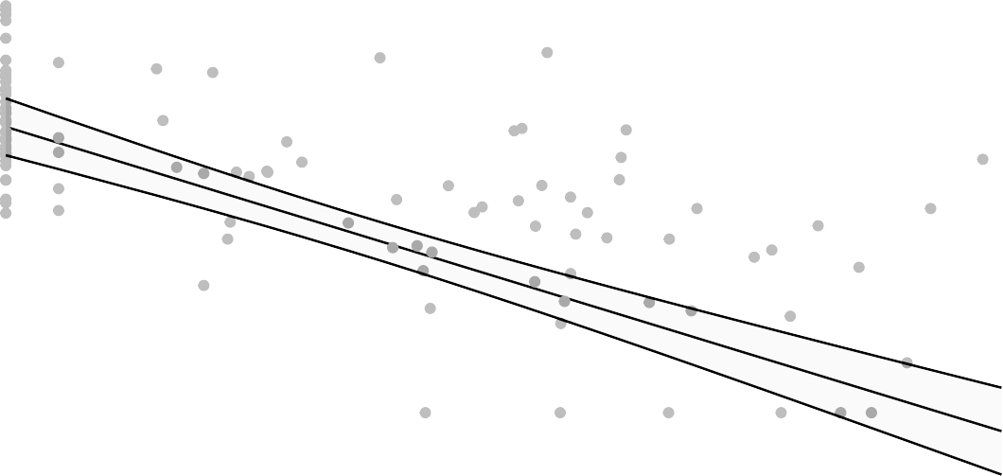
7

6

5

4

3

2 3 4
log VL Day2 PostChallenge NasalSwab Subgenomic
log PsVNA ID80 2 weeks prior challenge

Figure 6.4.95

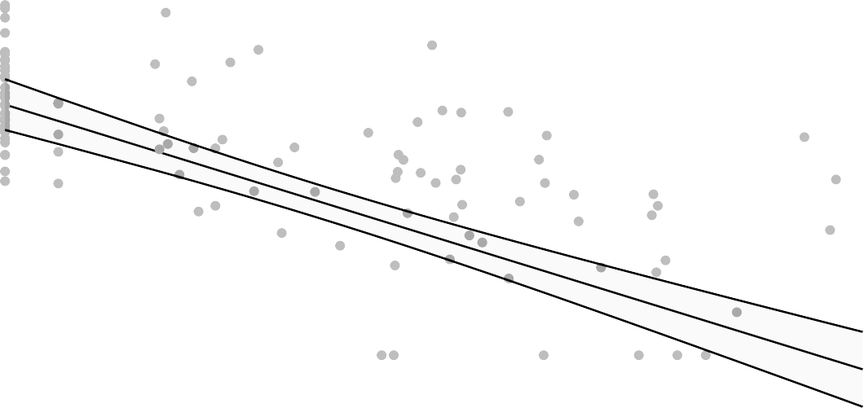
7

6

5

4

3

2 3 4

log PsVNA ID80 day challenge
log VL Day2 PostChallenge NasalSwab Subgenomic
Figure 6.4.96

Binary Viral Load
For binary viral load, a logistic model is fit with an intercept and one main effect for virus-specific antibody. The notation is the same as in Section 6.4.1, except now y_{jk} represents a binary response. As in the previous section, several models will be tried and the best one selected by cross-validation. Instead of comparing the models using adjusted R-squared, we use the binary analog, the adjusted coefficient of discrimination (Tjur, 2009, Fay et al., 2012). The models tried are the following: the logistic model:
log_{e}{µ_{jk}/(1 − µ_{jk})} = β₀ + β₁x_{jk}
Analogously to Section 6.4.1, the linear predictor portion of the model may be modeled in different ways: it could be fit as a segmented line with 2 breakpoints, or fit with natural cubic splines with 5 degrees of freedom. As in section 6.4.1, the best model by cross-validation will be fit to all of the data (enforcing monotonicity if needed), with confidence intervals on the prediction calculated using the parametric formula as above or nonparametric bootstrap (for segmented regression).
Table 6.4.2: Model Selection Results Using Single Virus-Specific Antibody to Predict Post Challenge Viral Load - Binary
Virus-Specific | Binary Viral Load | Model Selected | Adjusted CoD | Figure Number
log MSD ECL 2 | bin VL Day2 | ns5 | 1.000 | 6.4.131
weeks prior challenge  log MSD ECL day | PostChallenge  bin VL Day2 | ns5 | 1.000 | 6.4.132
challenge  log PsVNA ID50 | PostChallenge  bin VL Day2 | ns5 | 1.000 | 6.4.133
2 weeks prior challenge  log PsVNA ID80 | PostChallenge  bin VL Day2 | ns5 | 1.000 | 6.4.136
day challenge  log MN day | PostChallenge  bin VL Day2 | ns5 | 0.475 | 6.4.130
challenge | PostChallenge
 | NasalSwab N1
log MSD ECL 2 | bin VL Day2 | ns5 | 0.280 | 6.4.107
weeks prior challenge  log MSD ECL 2 | PostChallenge  bin VL Day2 | log | 0.259 | 6.4.99
weeks prior challenge  log MSD ECL day | PostChallenge  bin VL Day2 | ns5 | 0.250 | 6.4.108
challenge  log PsVNA ID50 | PostChallenge  bin VL Day2 | log | 0.223 | 6.4.109
2 weeks prior challenge | PostChallenge

Antibody

NasalSwab N1 NasalSwab N1 NasalSwab N1 NasalSwab N1

BAL Subgenomic BAL N1
BAL Subgenomic

log PsVNA ID50 day challenge
BAL Subgenomic bin VL Day2 PostChallenge NasalSwab Subgenomic
ns5 0.216 6.4.142

Virus-Specific Antibody
Binary Viral Load Model Selected Adjusted CoD Figure Number

log MSD ECL day challenge

log PsVNA ID80 2 weeks prior challenge
log MN day challenge
log MN 2 weeks prior challenge

log PsVNA ID80 day challenge

log PsVNA ID80 day challenge

log MSD ECL 2 weeks prior challenge
log MN day challenge

log MN 2 weeks prior challenge
log MN 2 weeks prior challenge

log PsVNA ID80 2 weeks prior challenge
log MN 2 weeks prior challenge

log PsVNA ID80 2 weeks prior challenge
bin VL Day2 PostChallenge OPswab Subgenomic bin VL Day2 PostChallenge
BAL Subgenomic bin VL Day2 PostChallenge BAL Subgenomic bin VL Day2 PostChallenge OPswab Subgenomic
bin VL Day2 PostChallenge BAL Subgenomic
bin VL Day2 PostChallenge NasalSwab Subgenomic bin VL Day2 PostChallenge OPswab Subgenomic bin VL Day2 PostChallenge NasalSwab Subgenomic bin VL Day2 PostChallenge
BAL Subgenomic
bin VL Day2 PostChallenge OPswab N1
bin VL Day2 PostChallenge BAL N1
bin VL Day2 PostChallenge NasalSwab Subgenomic bin VL Day2 PostChallenge NasalSwab Subgenomic
ns5 0.215 6.4.124
seg 0.210 6.4.111
log 0.209 6.4.106
ns5 0.203 6.4.121
log 0.199 6.4.112
log 0.196 6.4.144
seg 0.194 6.4.123
ns5 0.188 6.4.138
log 0.179 6.4.105
ns5 0.179 6.4.113
ns5 0.176 6.4.103
ns5 0.175 6.4.137
log 0.174 6.4.143

Virus-Specific Antibody
Binary Viral Load Model Selected Adjusted CoD Figure Number

log PsVNA ID50 2 weeks prior challenge
log PsVNA ID50 day challenge

log MSD ECL 2 weeks prior challenge
log MSD ECL day challenge
log MSD ECL 2 weeks prior challenge
log MSD ECL day challenge
log PsVNA ID80 2 weeks prior challenge

log PsVNA ID50 2 weeks prior challenge
log PsVNA ID80 day challenge

log MN day challenge

log MN day challenge
log PsVNA ID50 day challenge

log MSD ECL day challenge
bin VL Day2 PostChallenge NasalSwab Subgenomic bin VL Day2 PostChallenge
BAL Subgenomic
bin VL Day2 PostChallenge NasalSwab Subgenomic bin VL Day2 PostChallenge BAL N1
bin VL Day2 PostChallenge OPswab N1 bin VL Day2 PostChallenge OPswab N1 bin VL Day2 PostChallenge OPswab Subgenomic
bin VL Day2 PostChallenge OPswab Subgenomic bin VL Day2 PostChallenge OPswab Subgenomic bin VL Day2 PostChallenge OPswab Subgenomic bin VL Day2 PostChallenge BAL N1
bin VL Day2
PostChallenge OPswab Subgenomic
bin VL Day2 PostChallenge NasalSwab Subgenomic
log 0.173 6.4.141
log 0.164 6.4.110
log 0.160 6.4.139
log 0.157 6.4.100
log 0.153 6.4.115
log 0.153 6.4.116
log 0.152 6.4.127
log 0.149 6.4.125
log 0.149 6.4.128
seg 0.143 6.4.122
log 0.141 6.4.98
log 0.140 6.4.126
log 0.134 6.4.140

Antibody
Virus-Specific | Binary Viral Load | Model Selected | Adjusted CoD | Figure Number
log PsVNA ID80 | bin VL Day2 | log | 0.131 | 6.4.120
day challenge  log PsVNA ID80 | PostChallenge  bin VL Day2 | seg | 0.130 | 6.4.104
day challenge  log PsVNA ID80 | PostChallenge  bin VL Day2 | log | 0.116 | 6.4.119
2 weeks prior challenge  log PsVNA ID50 | PostChallenge  bin VL Day2 | log | 0.110 | 6.4.118
day challenge | PostChallenge
 | OPswab N1
log PsVNA ID50 | bin VL Day2 | seg | 0.109 | 6.4.101
2 weeks prior challenge log MN day | PostChallenge  bin VL Day2 | log | 0.104 | 6.4.114
challenge  log MN 2 weeks | PostChallenge  bin VL Day2 | log | 0.101 | 6.4.97
prior challenge  log PsVNA ID50 | PostChallenge  bin VL Day2 | log | 0.096 | 6.4.117
2 weeks prior challenge  log PsVNA ID50 | PostChallenge  bin VL Day2 | ns5 | 0.090 | 6.4.102
day challenge | PostChallenge
 | BAL N1
log PsVNA ID50 | bin VL Day2 | log | 0.012 | 6.4.134
day challenge  log MN 2 weeks | PostChallenge  bin VL Day2 | log | 0.007 | 6.4.129
prior challenge | PostChallenge

OPswab N1 BAL N1
OPswab N1

BAL N1

OPswab N1 BAL N1
OPswab N1

NasalSwab N1

log PsVNA ID80 2 weeks prior challenge
NasalSwab N1 bin VL Day2 PostChallenge NasalSwab N1
log -0.003 6.4.135

There are 28 pairs of virus-specific antibodies/viral loads (out of 48 total pairs) where the best model fit is logistic; 5 where the best model fit is segmented (with 2 breakpoints); and 15 where the best model fit is natural cubic splines with 5 degrees of freedom.

Predicted Values
log

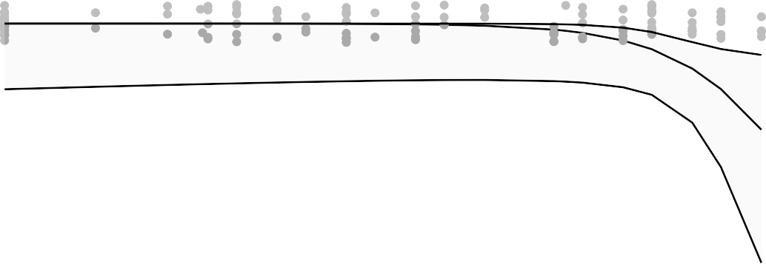
1.00

0.75
bin VL Day2 PostChallenge BAL N1

0.50

0.25

0.00

log
2 3 4
log MN 2 weeks prior challenge

Figure 6.4.97

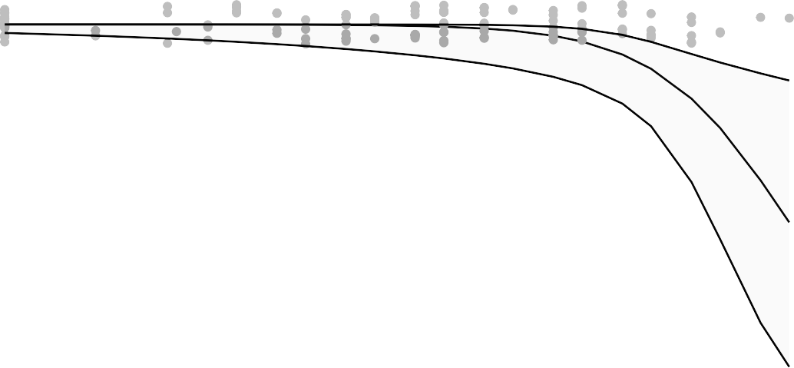
1.00

0.75
bin VL Day2 PostChallenge BAL N1

0.50

0.25

0.00

2 3 4
log MN day challenge

Figure 6.4.98

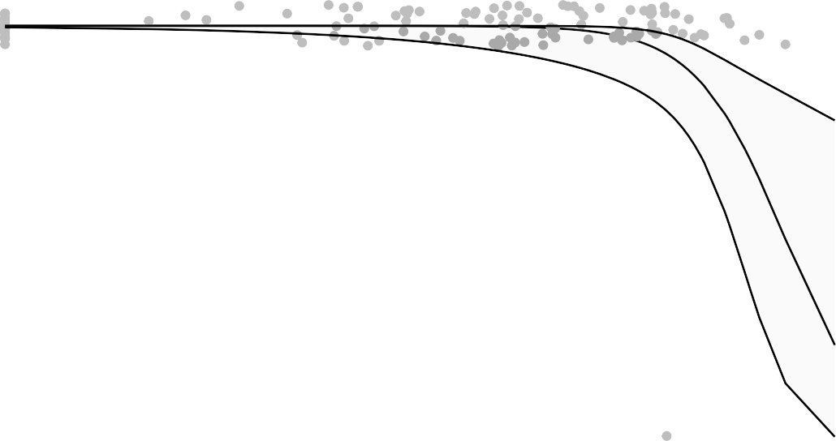
1.00

0.75
bin VL Day2 PostChallenge BAL N1

0.50

0.25

0.00

log
3 4 5 6
log MSD ECL 2 weeks prior challenge

Figure 6.4.99

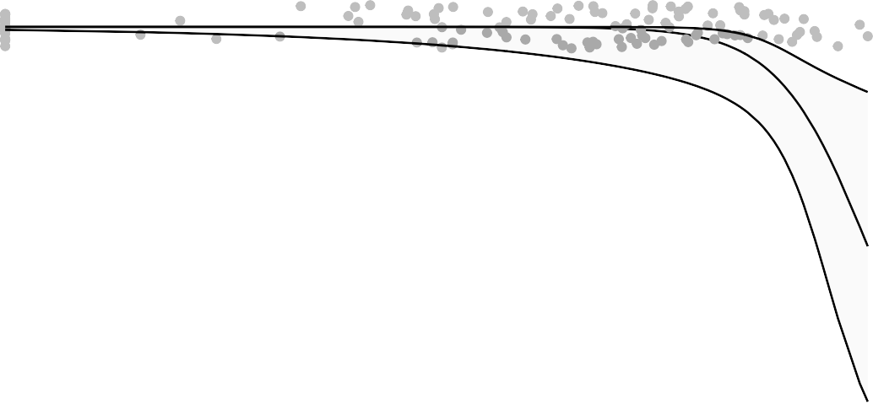
1.00

0.75
bin VL Day2 PostChallenge BAL N1

0.50

0.25

0.00

3 4 5 6

log MSD ECL day challenge
Figure 6.4.100

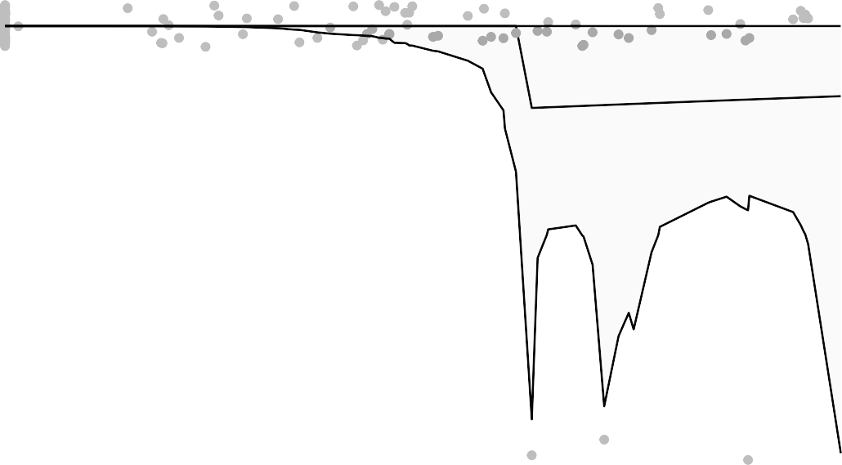
1.00

0.75
bin VL Day2 PostChallenge BAL N1

0.50

0.25

0.00

3 4 5

log PsVNA ID50 2 weeks prior challenge
Logistic regression to address non−monotonicity
Figure 6.4.101

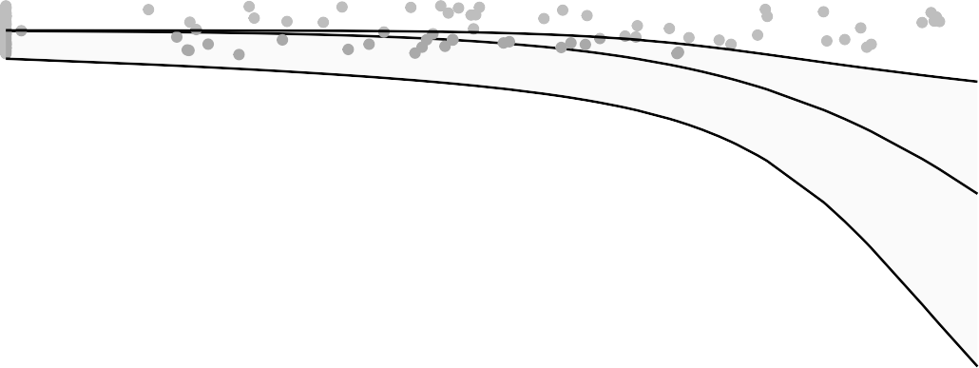
1.00

0.75
bin VL Day2 PostChallenge BAL N1

0.50

0.25

0.00

3 4 5

log PsVNA ID50 2 weeks prior challenge
Figure 6.4.101.1

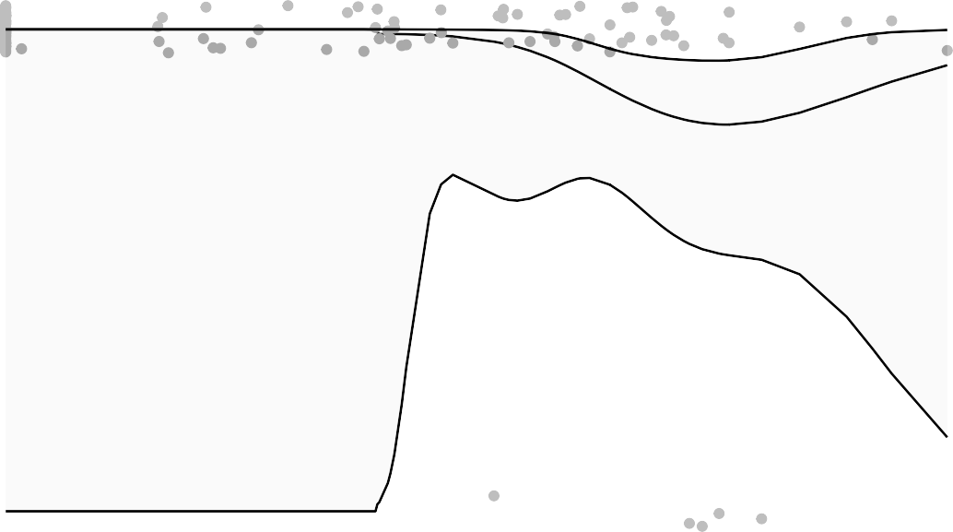
1.00

0.75
bin VL Day2 PostChallenge BAL N1

0.50

0.25

0.00

3 4
log PsVNA ID50 day challenge
Logistic regression to address non−monotonicity

Figure 6.4.102

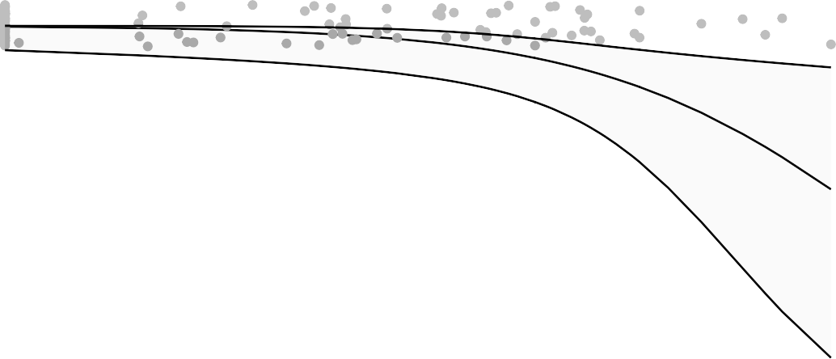
1.00

0.75
bin VL Day2 PostChallenge BAL N1

0.50

0.25

0.00

3 4
log PsVNA ID50 day challenge

Figure 6.4.102.1

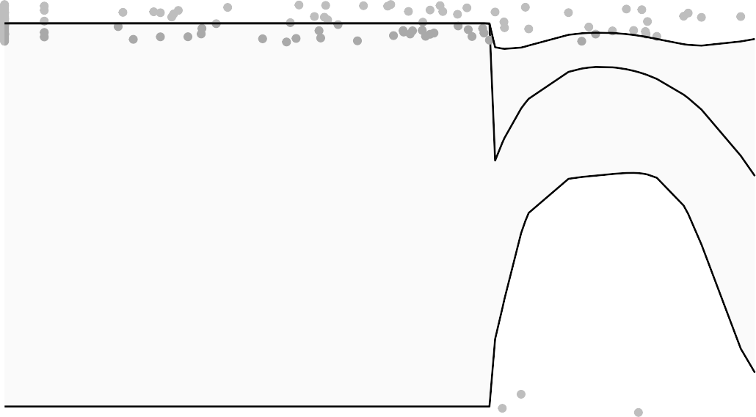
1.00

0.75
bin VL Day2 PostChallenge BAL N1

0.50

0.25

0.00

2 3 4
log PsVNA ID80 2 weeks prior challenge
Logistic regression to address non−monotonicity

Figure 6.4.103

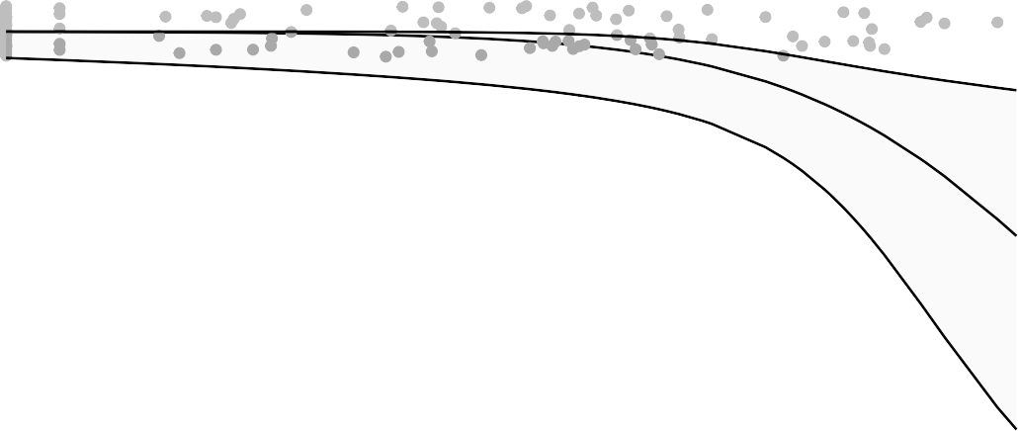
1.00

0.75
bin VL Day2 PostChallenge BAL N1

0.50

0.25

0.00

2 3 4

log PsVNA ID80 2 weeks prior challenge
Figure 6.4.103.1

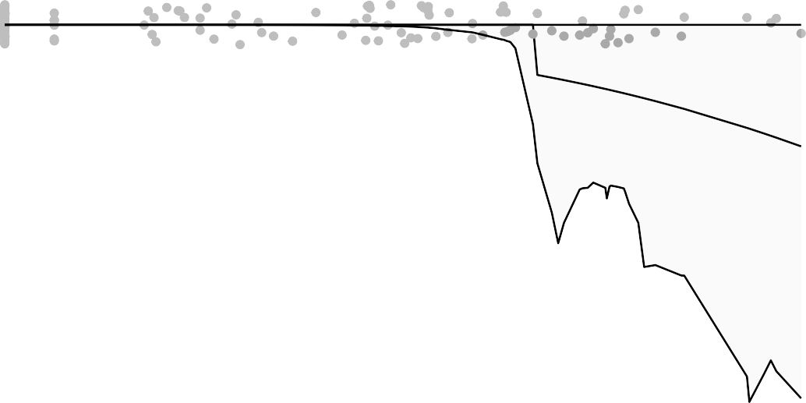
1.00

0.75
bin VL Day2 PostChallenge BAL N1

0.50

0.25

0.00

2 3 4

log PsVNA ID80 day challenge

Logistic regression to address non−monotonicity
Figure 6.4.104

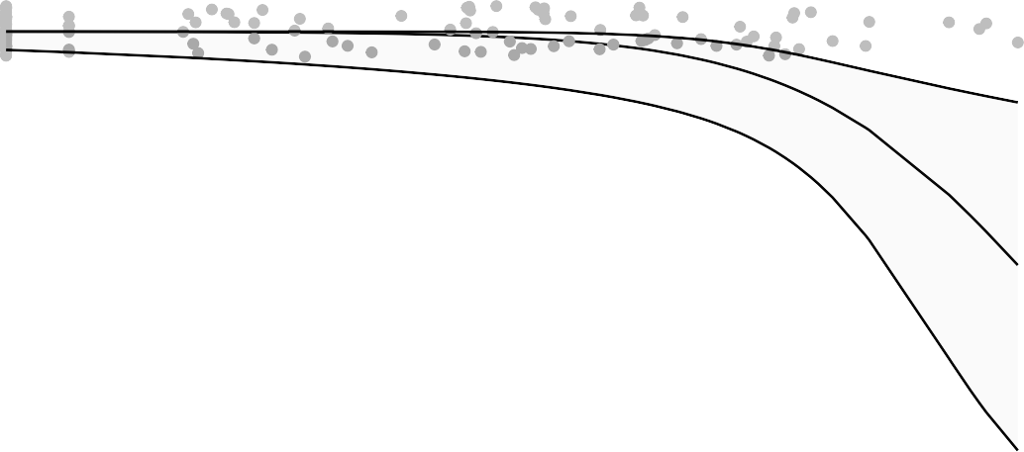
1.00

0.75
bin VL Day2 PostChallenge BAL N1

0.50

0.25

0.00

2 3 4

log PsVNA ID80 day challenge
Figure 6.4.104.1

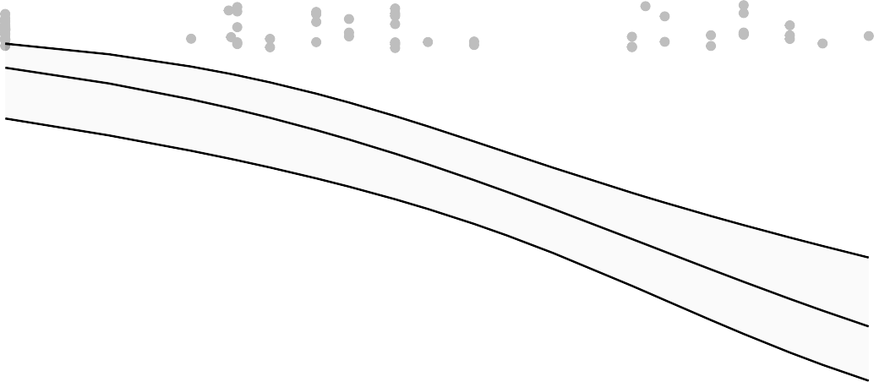
1.00
bin VL Day2 PostChallenge BAL Subgenomic

0.75

0.50

0.25

0.00

log
2 3 4
log MN 2 weeks prior challenge

Figure 6.4.105

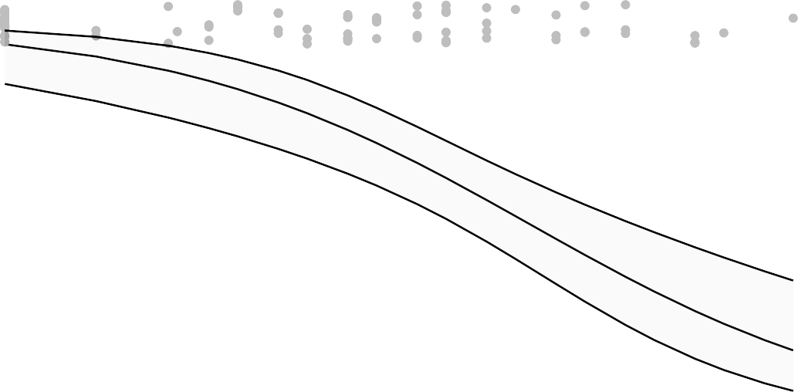
1.00
bin VL Day2 PostChallenge BAL Subgenomic

0.75

0.50

0.25

0.00

2 3 4
log MN day challenge

Figure 6.4.106

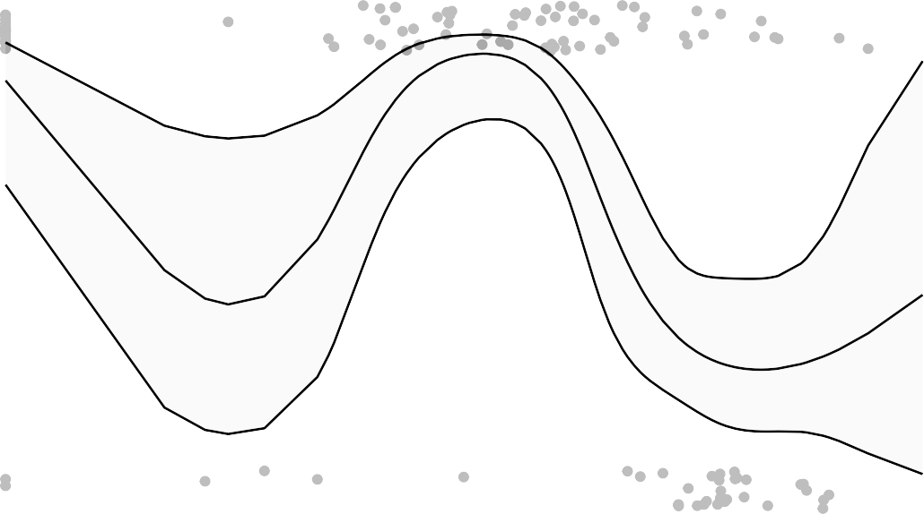
1.00
bin VL Day2 PostChallenge BAL Subgenomic

0.75

0.50

0.25

0.00

3 4 5 6

log MSD ECL 2 weeks prior challenge

Logistic regression to address non−monotonicity
Figure 6.4.107


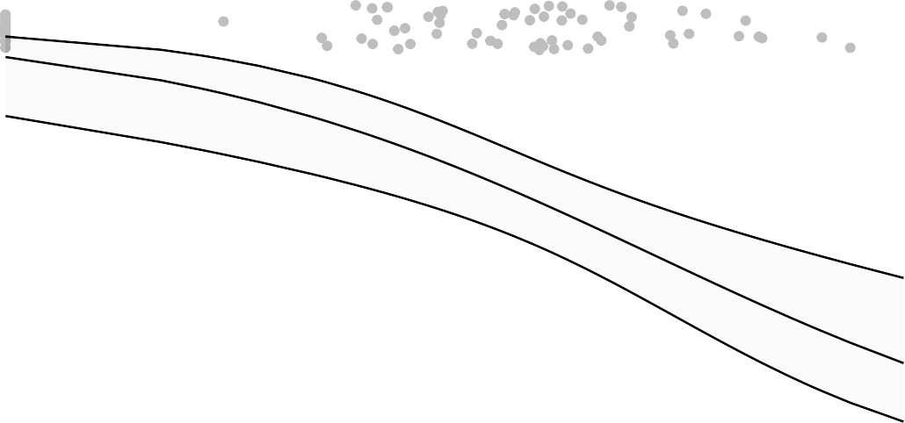
1.00
bin VL Day2 PostChallenge BAL Subgenomic

0.75

0.50

0.25

0.00

3 4 5 6

log MSD ECL 2 weeks prior challenge
Figure 6.4.107.1


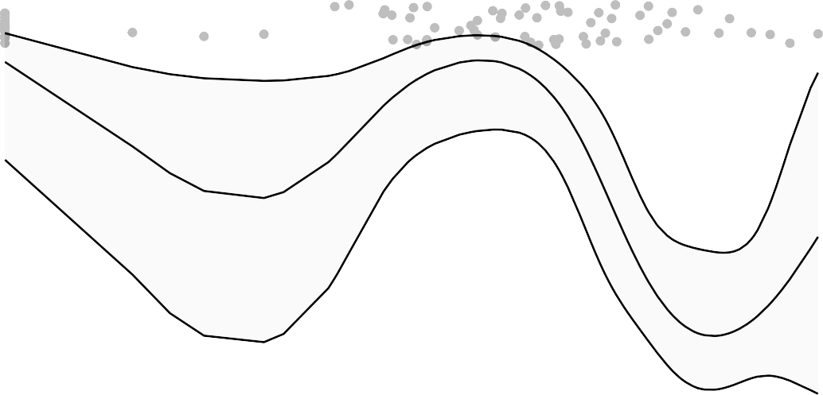
1.00
bin VL Day2 PostChallenge BAL Subgenomic

0.75

0.50

0.25

0.00

3 4 5 6

log MSD ECL day challenge

Logistic regression to address non−monotonicity
Figure 6.4.108


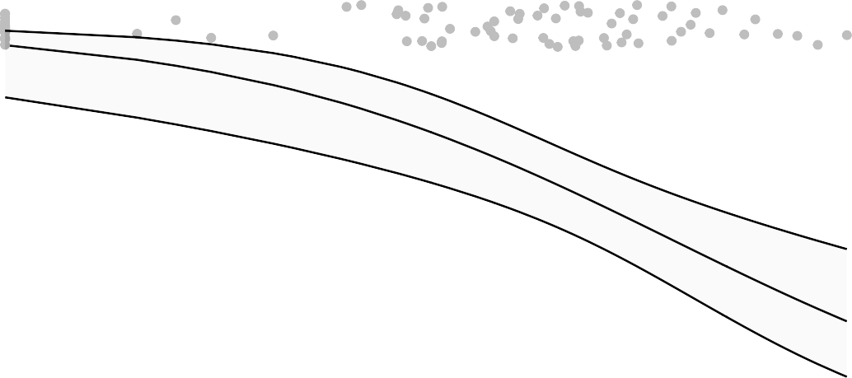
1.00
bin VL Day2 PostChallenge BAL Subgenomic

0.75

0.50

0.25

0.00

3 4 5 6

log MSD ECL day challenge
Figure 6.4.108.1

1.00
bin VL Day2 PostChallenge BAL Subgenomic

0.75

0.50

0.25

0.00

3 4 5

log
log PsVNA ID50 2 weeks prior challenge
Figure 6.4.109

1.00
bin VL Day2 PostChallenge BAL Subgenomic

0.75

0.50

0.25

0.00

3 4
log PsVNA ID50 day challenge

Figure 6.4.110

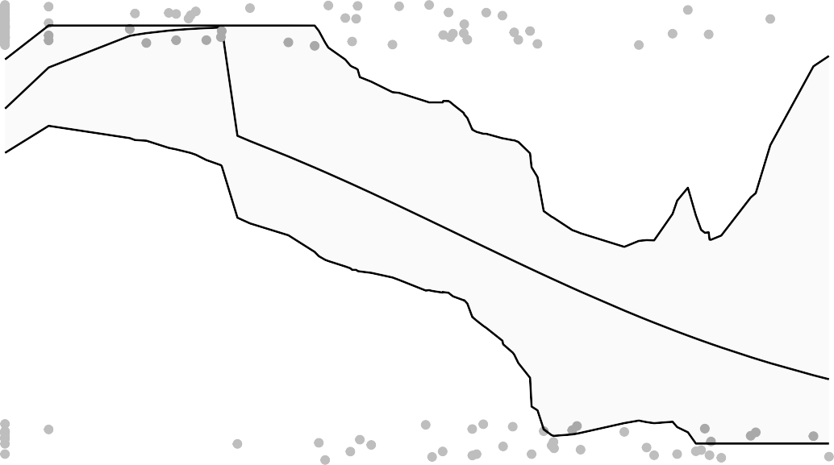
1.00
bin VL Day2 PostChallenge BAL Subgenomic

0.75

0.50

0.25

0.00

2 3 4
log PsVNA ID80 2 weeks prior challenge

Logistic regression to address non−monotonicity

Figure 6.4.111

1.00
bin VL Day2 PostChallenge BAL Subgenomic

0.75

0.50

0.25

0.00

2 3 4

log PsVNA ID80 2 weeks prior challenge
Figure 6.4.111.1

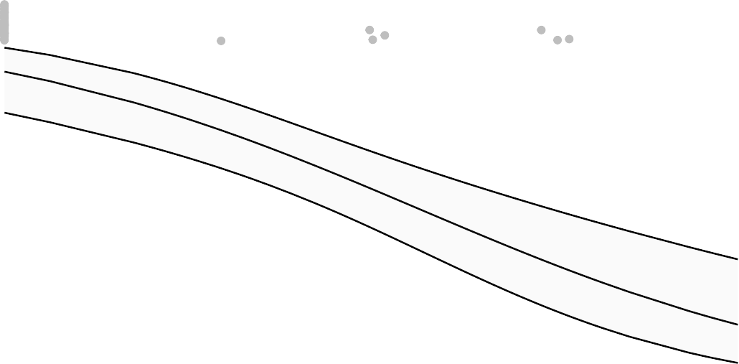
1.00
bin VL Day2 PostChallenge BAL Subgenomic

0.75

0.50

0.25

0.00

2 3 4

ns5
log PsVNA ID80 day challenge
Figure 6.4.112

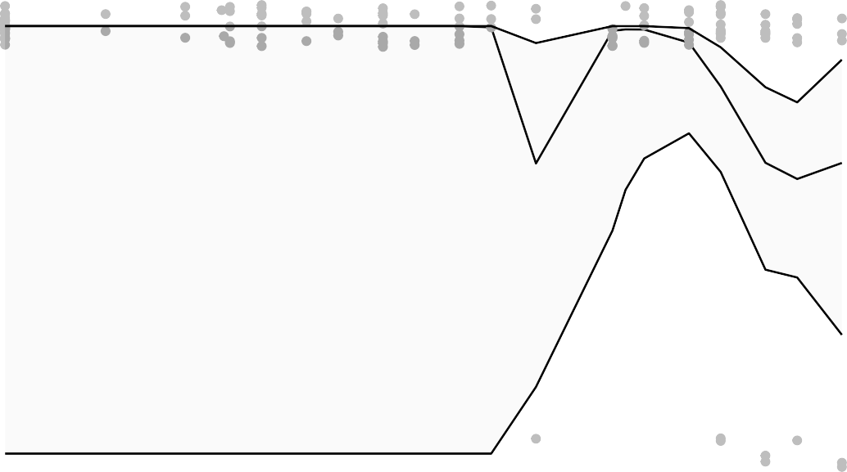
1.00
bin VL Day2 PostChallenge OPswab N1

0.75

0.50

0.25

0.00

2 3 4
log MN 2 weeks prior challenge

Figure 6.4.113

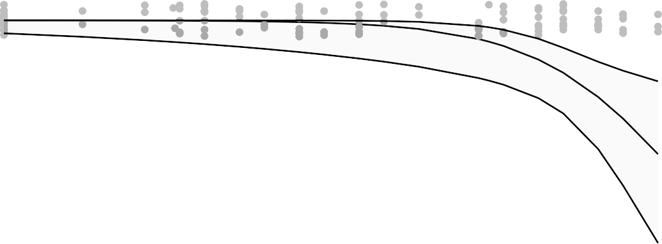
1.00
bin VL Day2 PostChallenge OPswab N1

0.75

0.50

0.25

0.00

log
2 3 4
log MN 2 weeks prior challenge

Figure 6.4.113.1

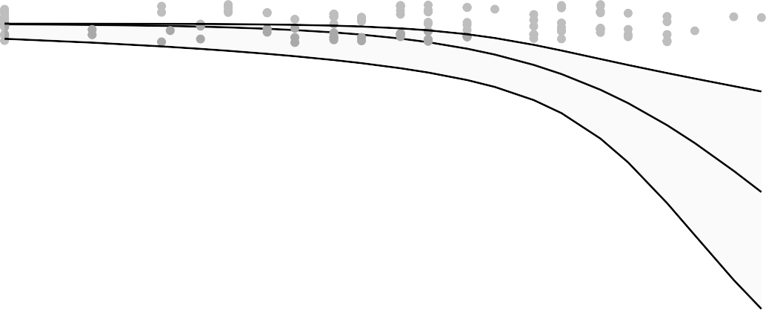
1.00
bin VL Day2 PostChallenge OPswab N1

0.75

0.50

0.25

0.00

2 3 4
log MN day challenge

Figure 6.4.114

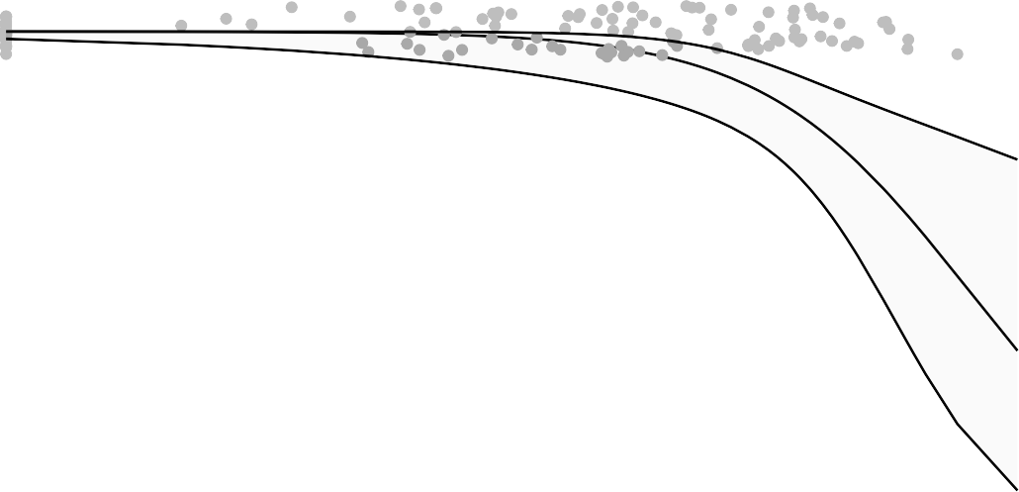
1.00
bin VL Day2 PostChallenge OPswab N1

0.75

0.50

0.25

0.00

3 4 5 6

log
log MSD ECL 2 weeks prior challenge
Figure 6.4.115

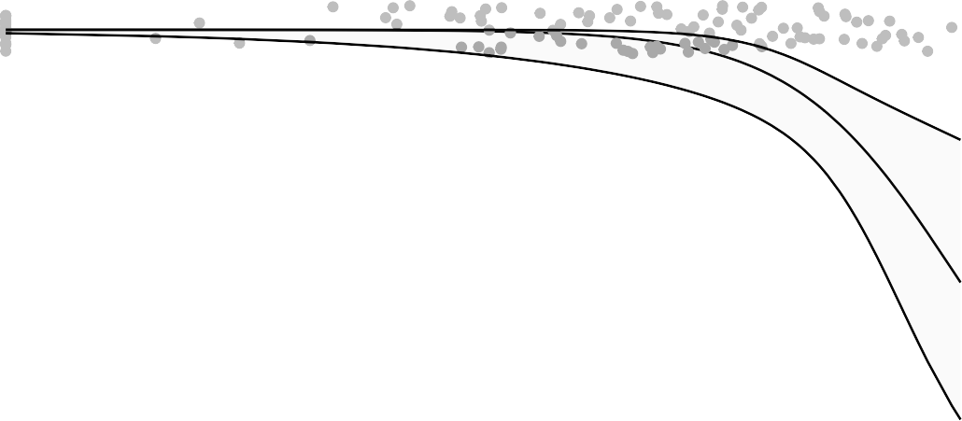
1.00
bin VL Day2 PostChallenge OPswab N1

0.75

0.50

0.25

0.00

3 4 5 6

log MSD ECL day challenge
Figure 6.4.116

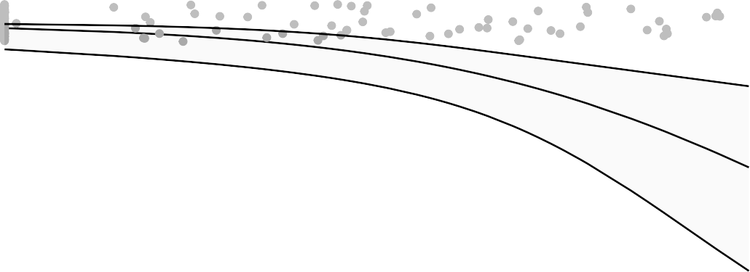
1.00
bin VL Day2 PostChallenge OPswab N1

0.75

0.50

0.25

0.00

3 4 5

log
log PsVNA ID50 2 weeks prior challenge
Figure 6.4.117

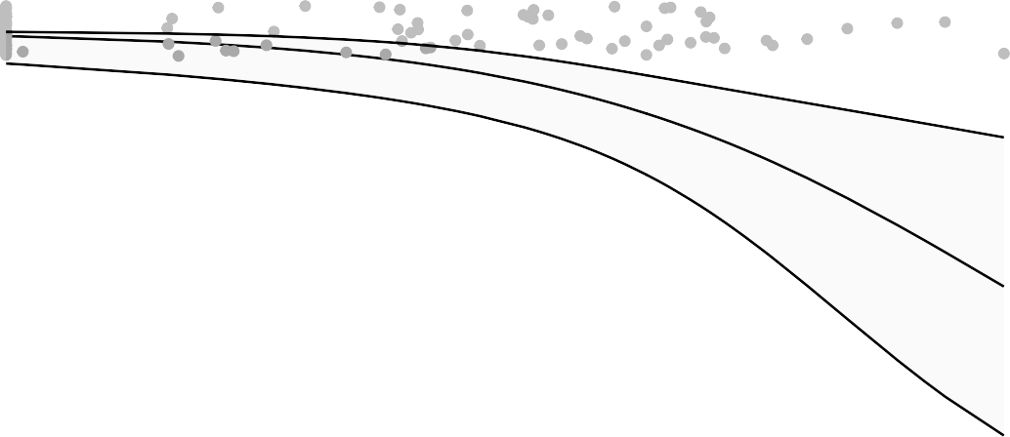
1.00
bin VL Day2 PostChallenge OPswab N1

0.75

0.50

0.25

0.00

3 4
log PsVNA ID50 day challenge

Figure 6.4.118

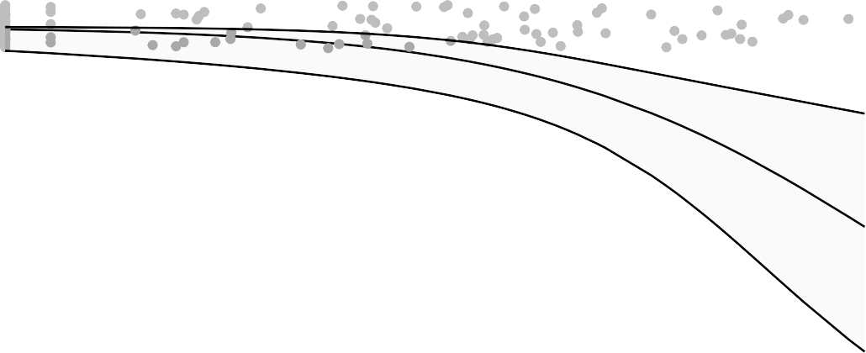
1.00
bin VL Day2 PostChallenge OPswab N1

0.75

0.50

0.25

0.00

log
2 3 4
log PsVNA ID80 2 weeks prior challenge

Figure 6.4.119

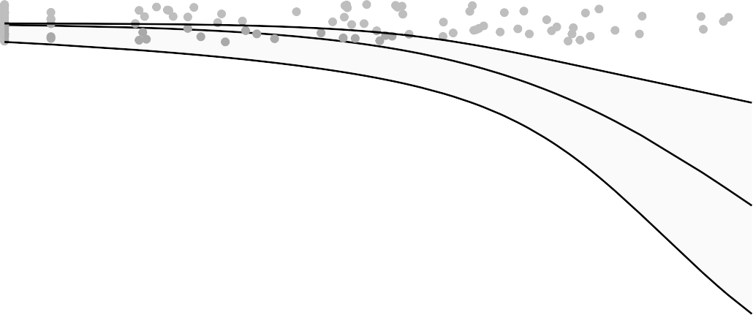
1.00
bin VL Day2 PostChallenge OPswab N1

0.75

0.50

0.25

0.00

2 3 4

log PsVNA ID80 day challenge
Figure 6.4.120

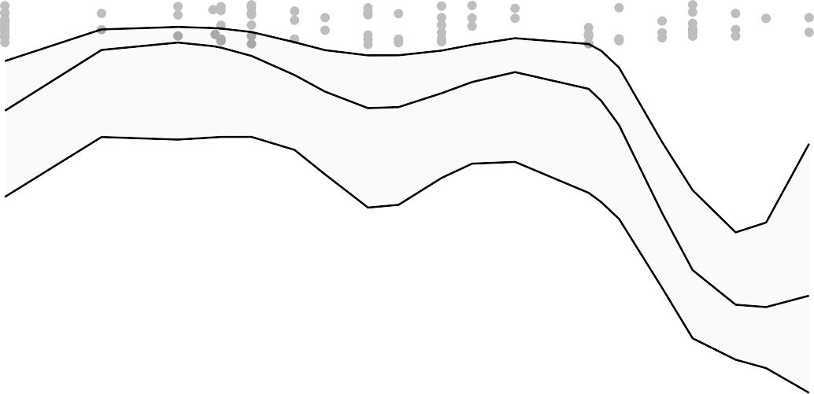
1.00
bin VL Day2 PostChallenge OPswab Subgenomic

0.75

0.50

0.25

0.00

2 3 4
log MN 2 weeks prior challenge

Logistic regression to address non−monotonicity
bin VL Day2 PostChallenge OPswab Subgenomic

Figure 6.4.121

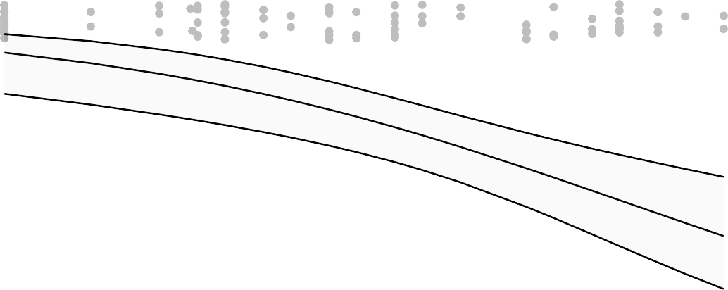
1.00

0.75

0.50

0.25

0.00

2 3 4
log MN 2 weeks prior challenge

Figure 6.4.121.1

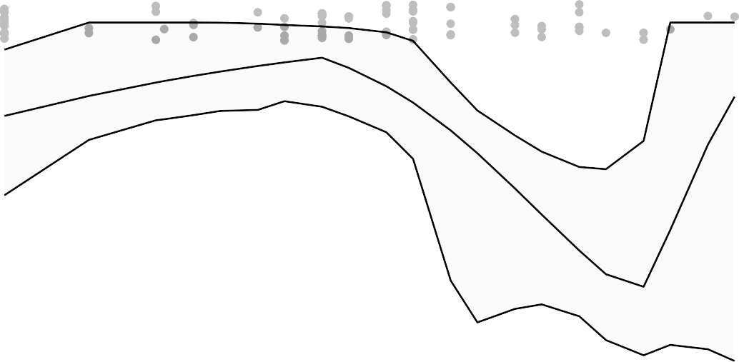
1.00
bin VL Day2 PostChallenge OPswab Subgenomic

0.75

0.50

0.25

0.00

2 3 4
log MN day challenge

Logistic regression to address non−monotonicity
bin VL Day2 PostChallenge OPswab Subgenomic

Figure 6.4.122

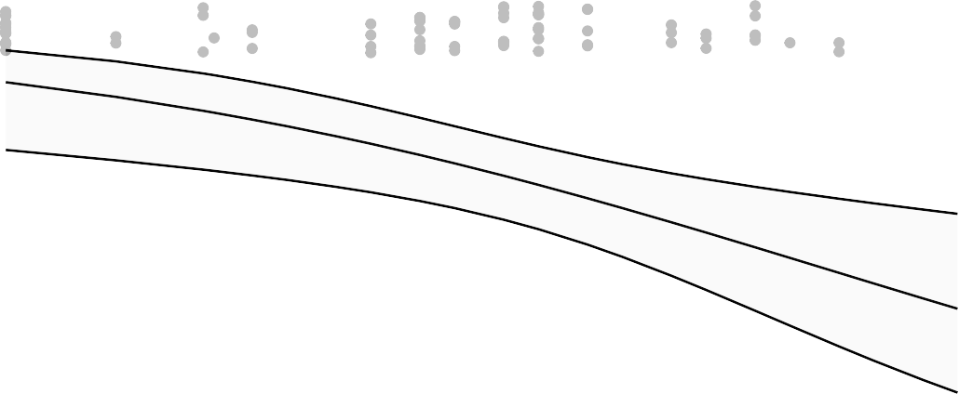
1.00

0.75

0.50

0.25

0.00

2 3 4
log MN day challenge

Figure 6.4.122.1

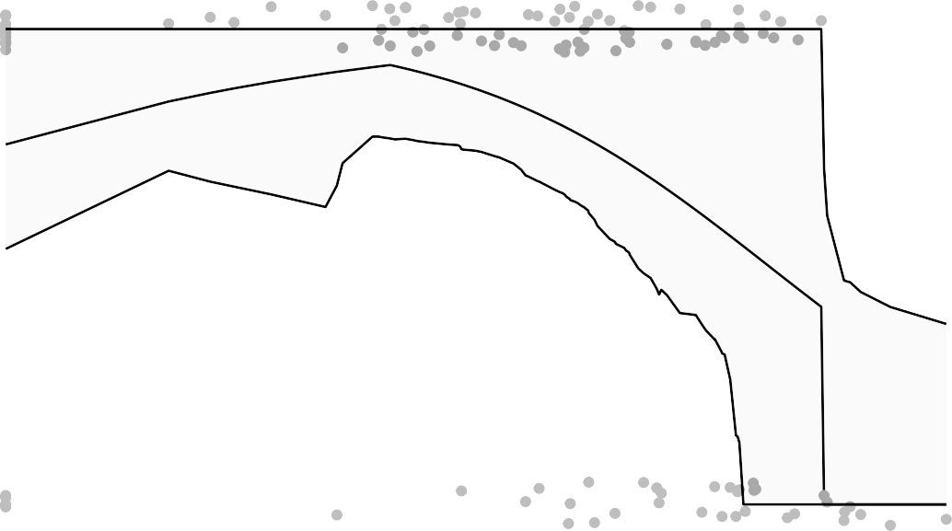
1.00
bin VL Day2 PostChallenge OPswab Subgenomic

0.75

0.50

0.25

0.00

3 4 5 6

log MSD ECL 2 weeks prior challenge

Logistic regression to address non−monotonicity
bin VL Day2 PostChallenge OPswab Subgenomic
Figure 6.4.123

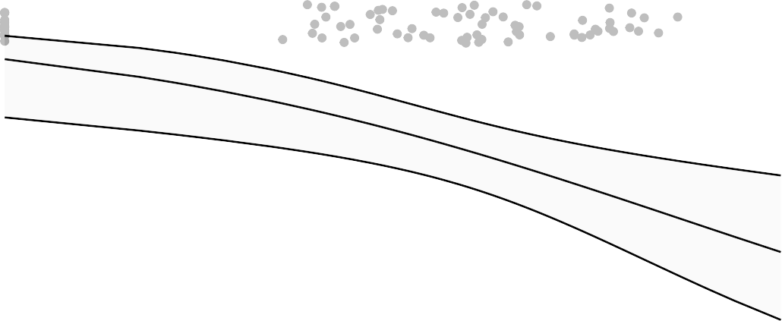
1.00

0.75

0.50

0.25

0.00

3 4 5 6

log MSD ECL 2 weeks prior challenge
Figure 6.4.123.1

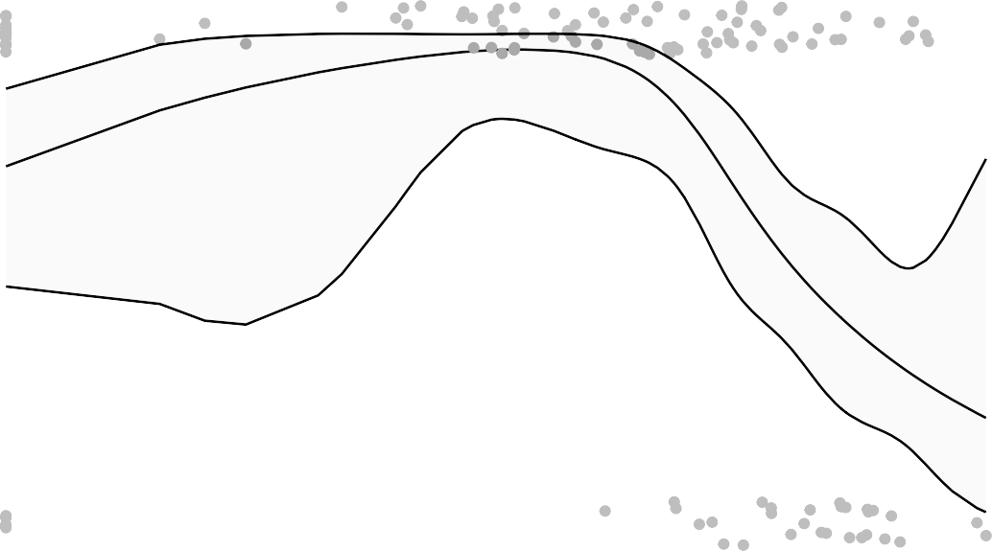
1.00
bin VL Day2 PostChallenge OPswab Subgenomic

0.75

0.50

0.25

0.00

3 4 5 6

log MSD ECL day challenge

Logistic regression to address non−monotonicity
bin VL Day2 PostChallenge OPswab Subgenomic
Figure 6.4.124


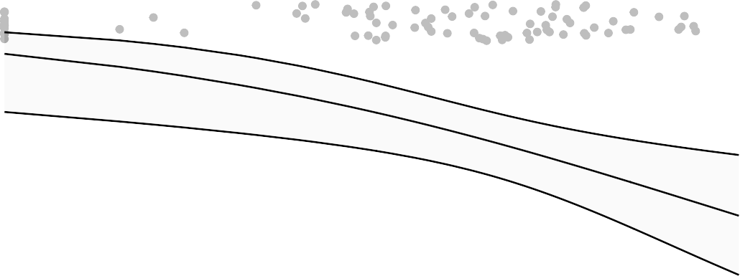
1.00

0.75

0.50

0.25

0.00

3 4 5 6

log MSD ECL day challenge
Figure 6.4.124.1

1.00
bin VL Day2 PostChallenge OPswab Subgenomic

0.75

0.50

0.25

0.00

3 4 5

log
bin VL Day2 PostChallenge OPswab Subgenomic
log PsVNA ID50 2 weeks prior challenge
Figure 6.4.125

1.00

0.75

0.50

0.25

0.00

3 4
log PsVNA ID50 day challenge

Figure 6.4.126

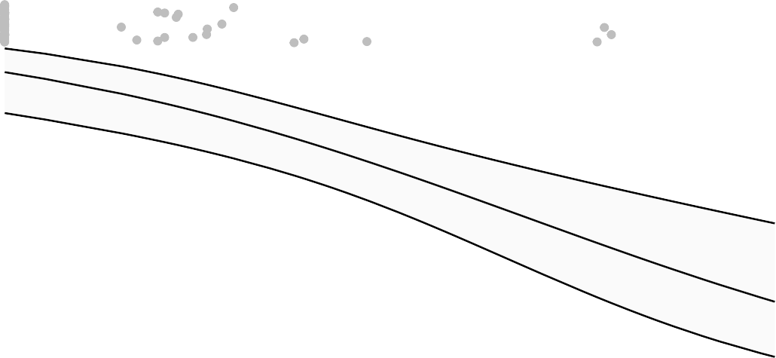
1.00
bin VL Day2 PostChallenge OPswab Subgenomic

0.75

0.50

0.25

0.00

log
bin VL Day2 PostChallenge OPswab Subgenomic
2 3 4
log PsVNA ID80 2 weeks prior challenge

Figure 6.4.127

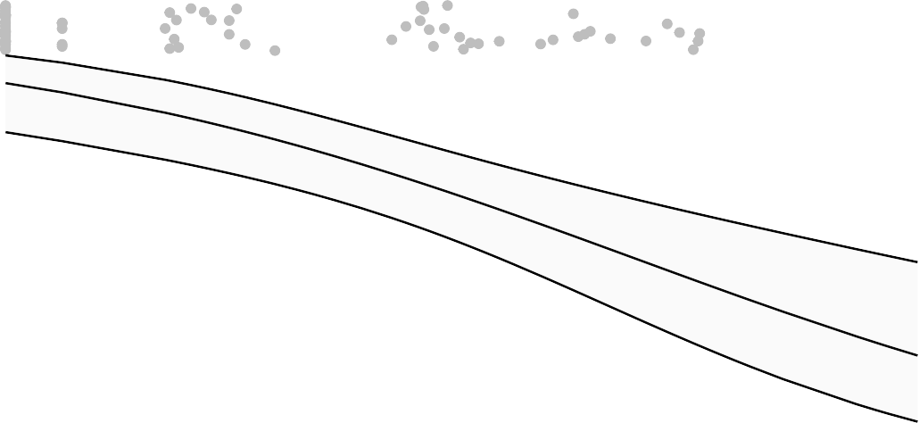
1.00

0.75

0.50

0.25

0.00

2 3 4

log PsVNA ID80 day challenge
Figure 6.4.128

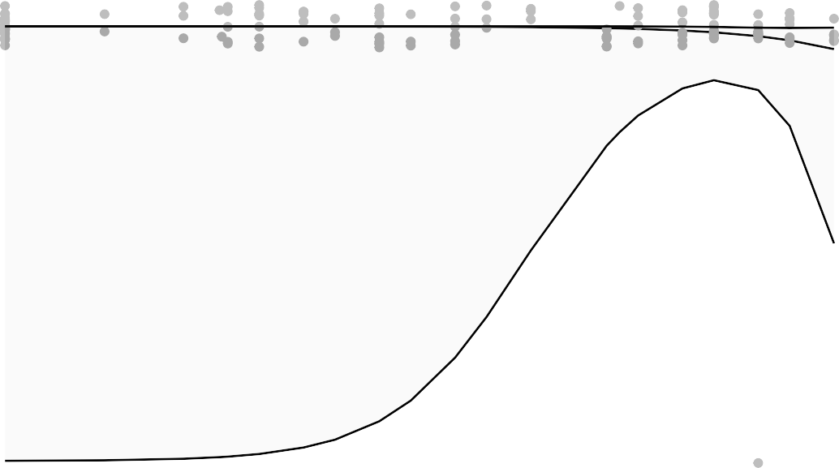
1.00
bin VL Day2 PostChallenge NasalSwab N1

0.75

0.50

0.25

0.00

ns5

2 3 4
log MN 2 weeks prior challenge

Figure 6.4.129

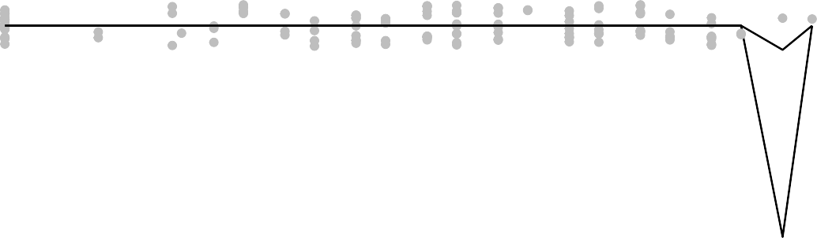
1.00
bin VL Day2 PostChallenge NasalSwab N1

0.75

0.50

0.25

0.00

2 3 4
log MN day challenge

Figure 6.4.130

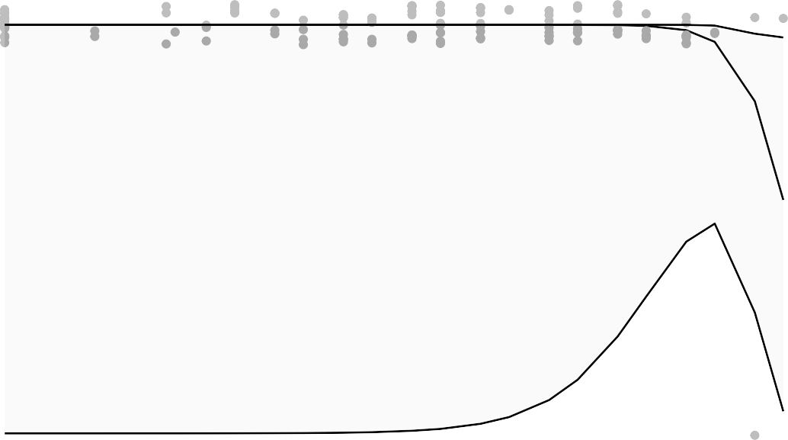
1.00
bin VL Day2 PostChallenge NasalSwab N1

0.75

0.50

0.25

0.00

ns5

2 3 4
log MN day challenge

Figure 6.4.130.1

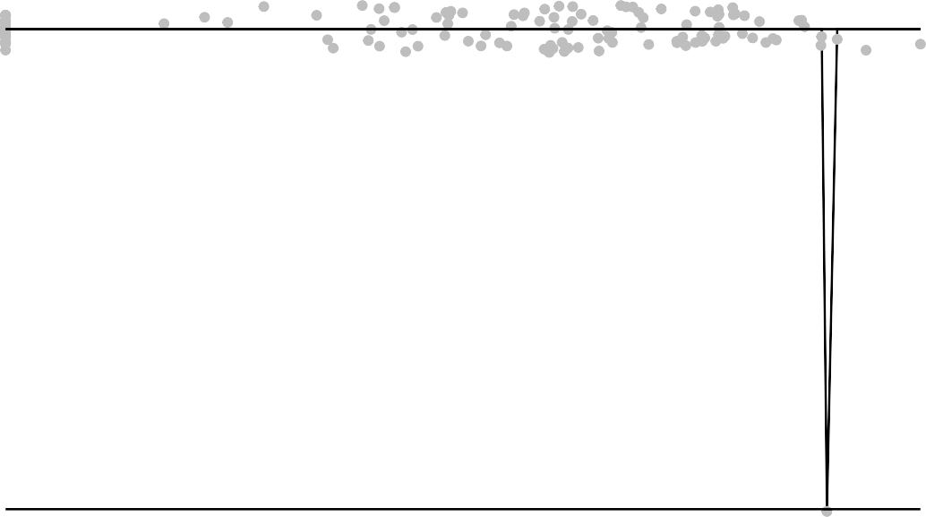
1.00
bin VL Day2 PostChallenge NasalSwab N1

0.75

0.50

0.25

0.00
3 4 5 6

log MSD ECL 2 weeks prior challenge
Figure 6.4.131

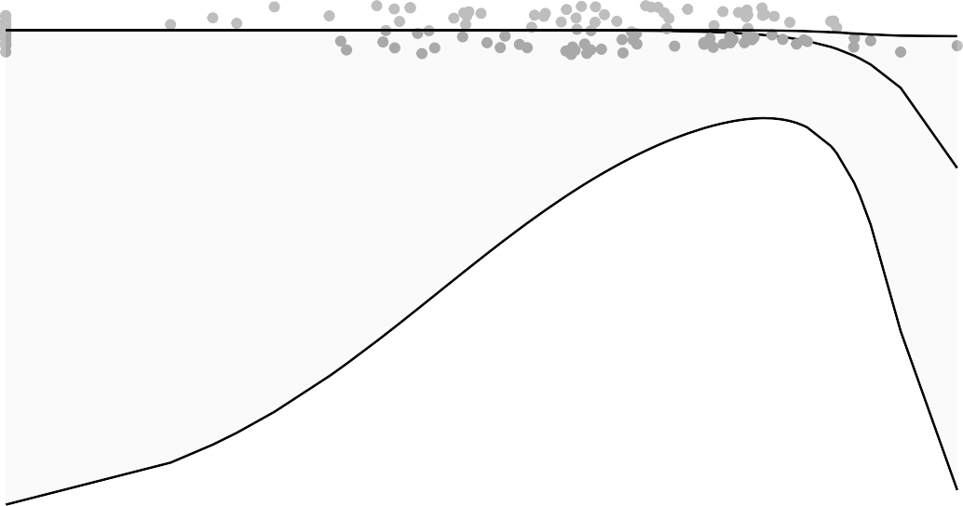
1.00
bin VL Day2 PostChallenge NasalSwab N1

0.75

0.50

0.25

0.00
3 4 5 6

ns5
log MSD ECL 2 weeks prior challenge
Figure 6.4.131.1

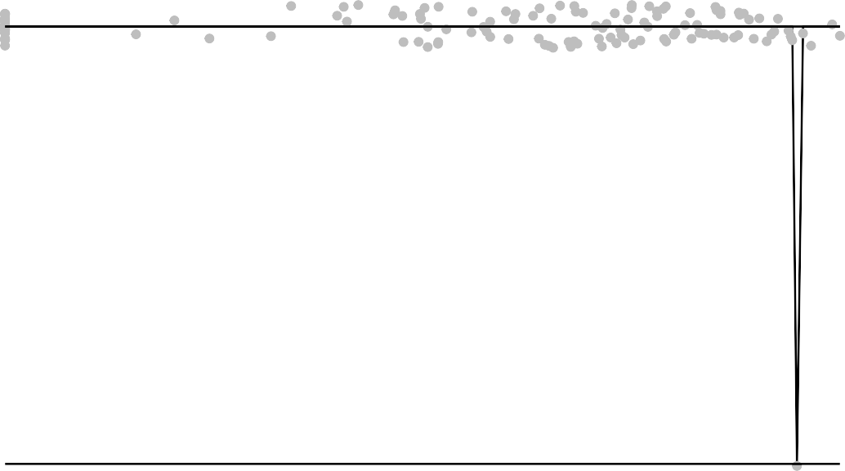
1.00
bin VL Day2 PostChallenge NasalSwab N1

0.75

0.50

0.25

0.00
3 4 5 6

log MSD ECL day challenge
Figure 6.4.132

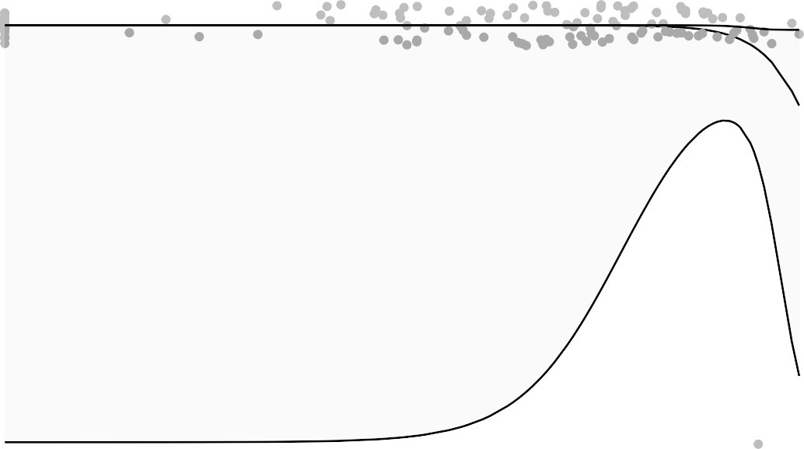
1.00
bin VL Day2 PostChallenge NasalSwab N1

0.75

0.50

0.25

0.00
3 4 5 6

ns5
log MSD ECL day challenge
Figure 6.4.132.1

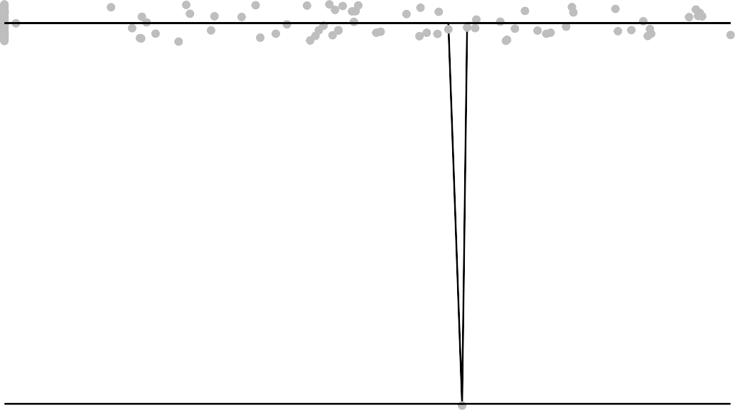
1.00
bin VL Day2 PostChallenge NasalSwab N1

0.75

0.50

0.25

0.00
3 4 5

log PsVNA ID50 2 weeks prior challenge
Figure 6.4.133

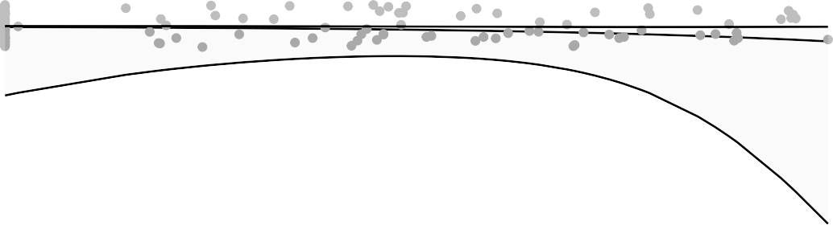
1.00
bin VL Day2 PostChallenge NasalSwab N1

0.75

0.50

0.25

0.00
3 4 5

log
log PsVNA ID50 2 weeks prior challenge
Figure 6.4.133.1

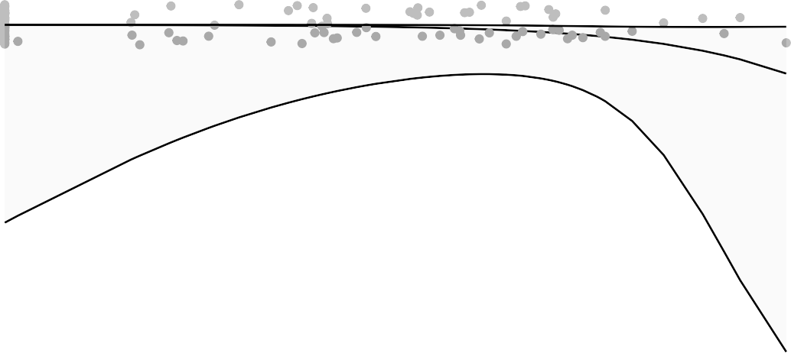
1.00
bin VL Day2 PostChallenge NasalSwab N1

0.75

0.50

0.25

0.00

3 4
log PsVNA ID50 day challenge

Figure 6.4.134

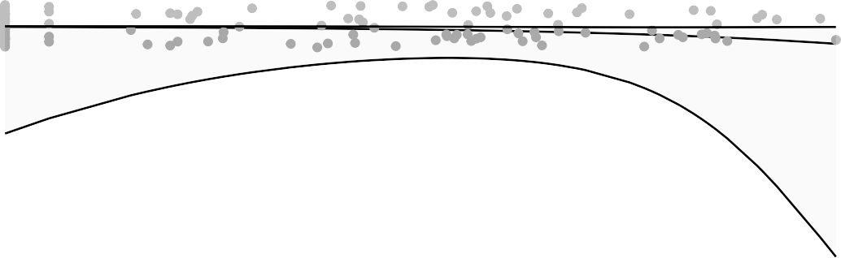
1.00
bin VL Day2 PostChallenge NasalSwab N1

0.75

0.50

0.25

0.00

ns5

2 3 4
log PsVNA ID80 2 weeks prior challenge

Figure 6.4.135

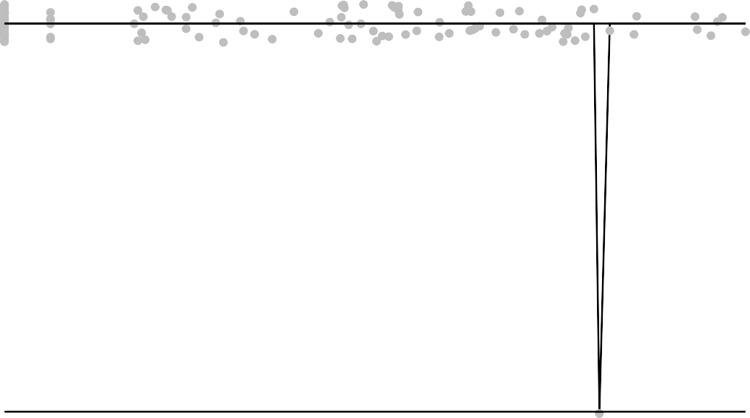
1.00
bin VL Day2 PostChallenge NasalSwab N1

0.75

0.50

0.25

0.00
2 3 4

log PsVNA ID80 day challenge
Figure 6.4.136

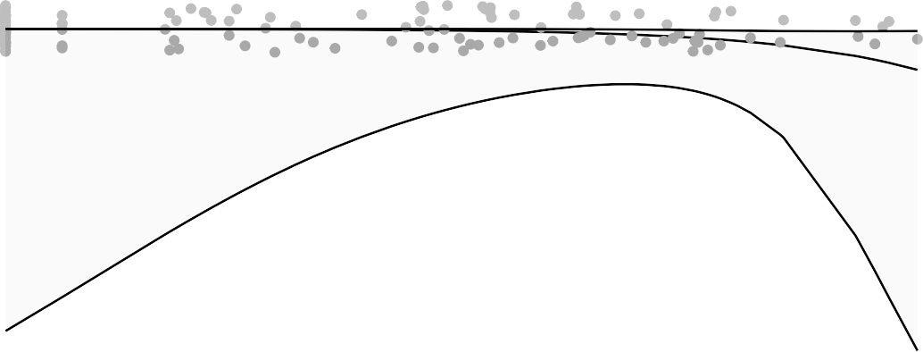
1.00
bin VL Day2 PostChallenge NasalSwab N1

0.75

0.50

0.25

0.00
2 3 4

ns5
bin VL Day2 PostChallenge NasalSwab Subgenomic
log PsVNA ID80 day challenge
Figure 6.4.136.1

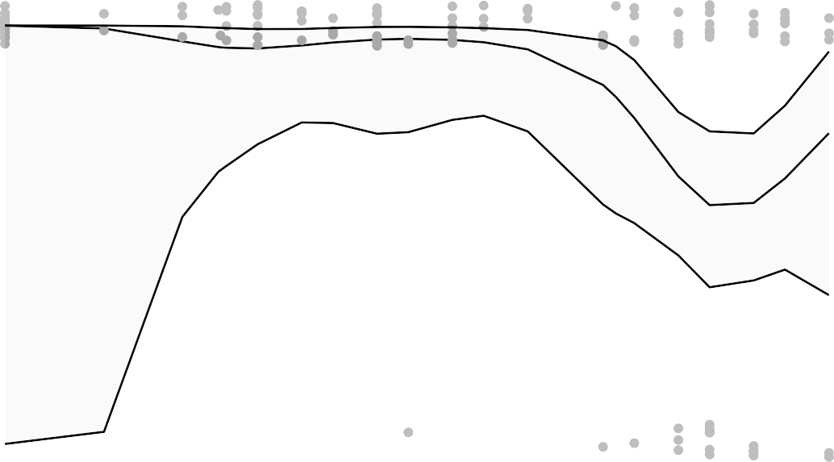
1.00

0.75

0.50

0.25

0.00

2 3 4
log MN 2 weeks prior challenge

Figure 6.4.137

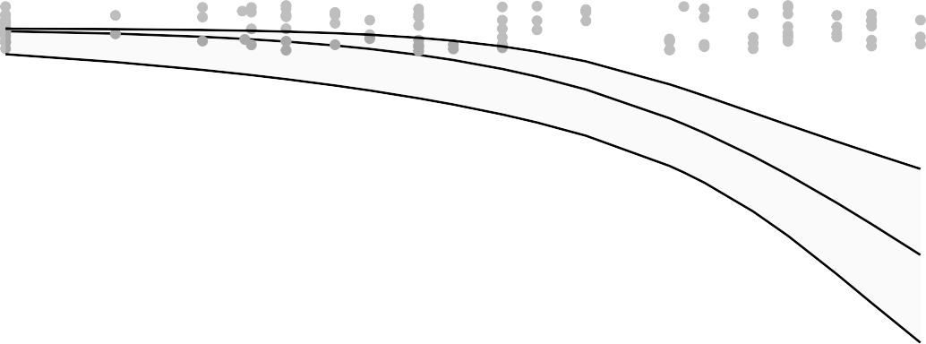
1.00
bin VL Day2 PostChallenge NasalSwab Subgenomic

0.75

0.50

0.25

0.00

ns5
bin VL Day2 PostChallenge NasalSwab Subgenomic
2 3 4
log MN 2 weeks prior challenge

Figure 6.4.137.1

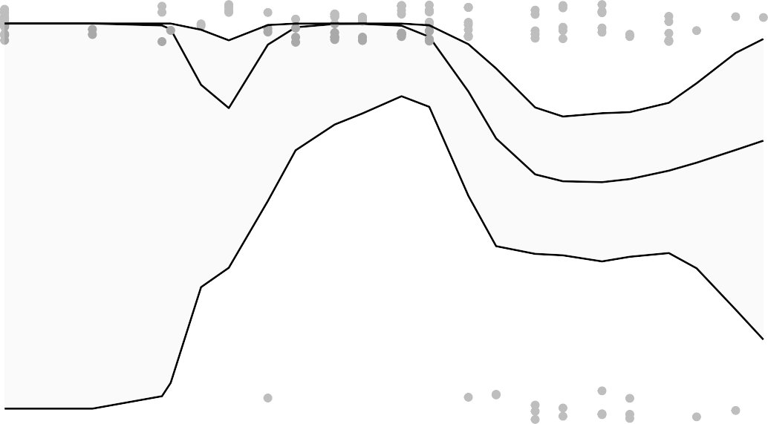
1.00

0.75

0.50

0.25

0.00

2 3 4
log MN day challenge

Figure 6.4.138

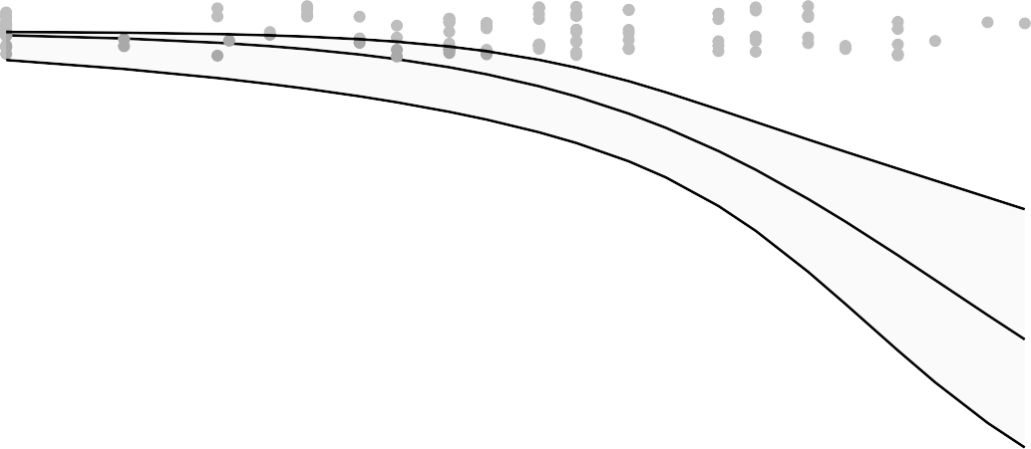
1.00
bin VL Day2 PostChallenge NasalSwab Subgenomic

0.75

0.50

0.25

0.00

log
bin VL Day2 PostChallenge NasalSwab Subgenomic
2 3 4
log MN day challenge

Figure 6.4.138.1

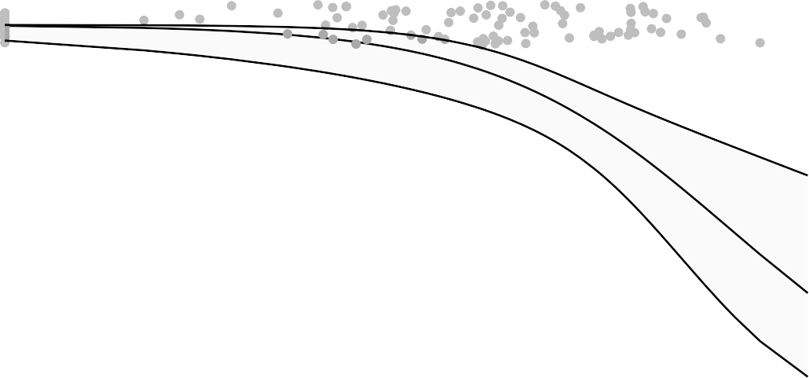
1.00

0.75

0.50

0.25

0.00

3 4 5 6

log MSD ECL 2 weeks prior challenge
Figure 6.4.139

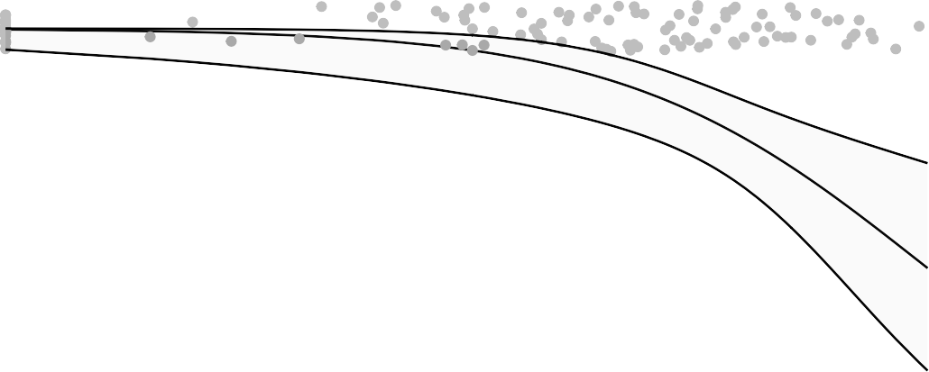
1.00
bin VL Day2 PostChallenge NasalSwab Subgenomic

0.75

0.50

0.25

0.00

3 4 5 6

log
bin VL Day2 PostChallenge NasalSwab Subgenomic
log MSD ECL day challenge
Figure 6.4.140

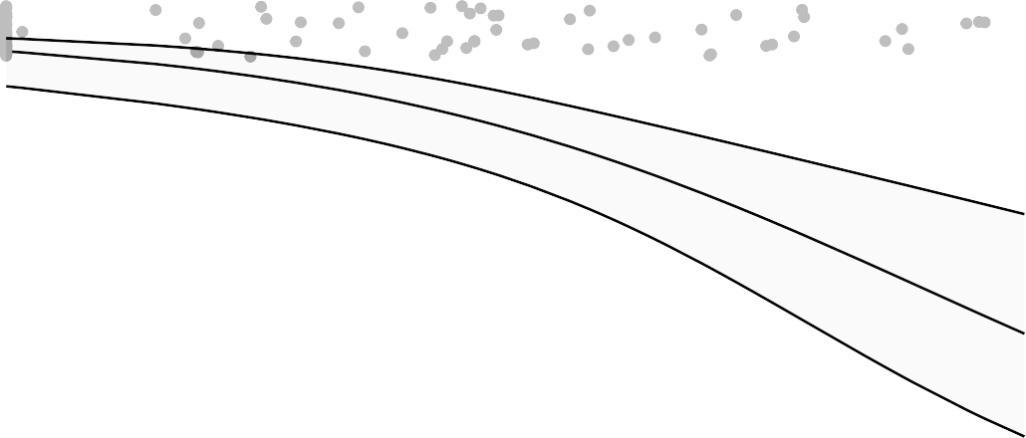
1.00

0.75

0.50

0.25

0.00

3 4 5

log PsVNA ID50 2 weeks prior challenge
Figure 6.4.141

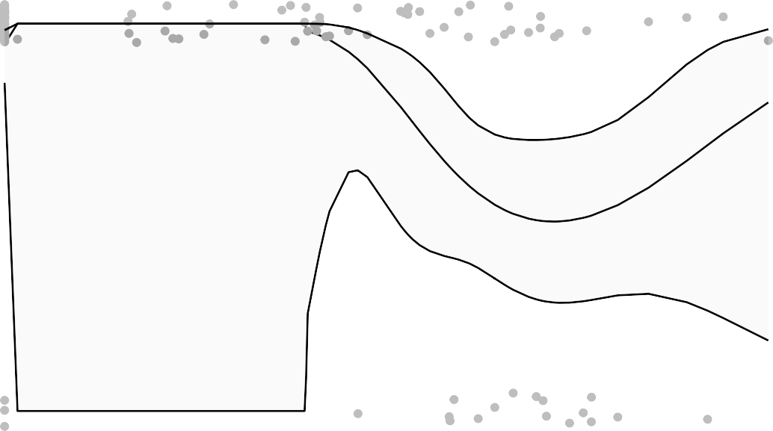
1.00
bin VL Day2 PostChallenge NasalSwab Subgenomic

0.75

0.50

0.25

0.00

3 4
log PsVNA ID50 day challenge

Logistic regression to address non−monotonicity
bin VL Day2 PostChallenge NasalSwab Subgenomic

Figure 6.4.142

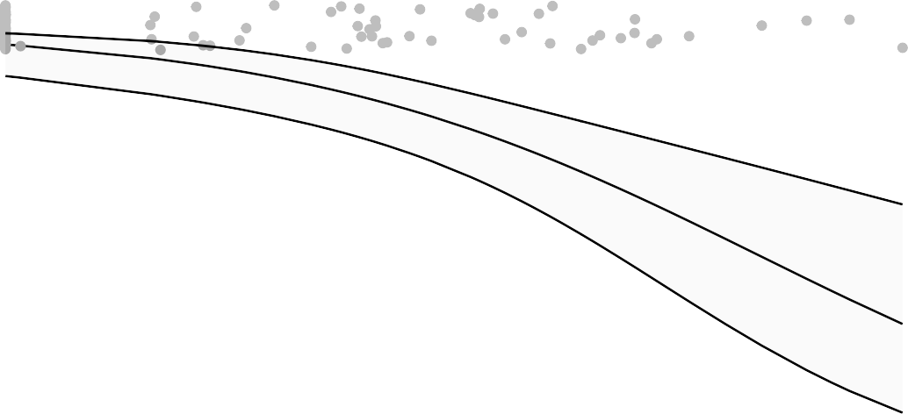
1.00

0.75

0.50

0.25

0.00

3 4
log PsVNA ID50 day challenge

Figure 6.4.142.1

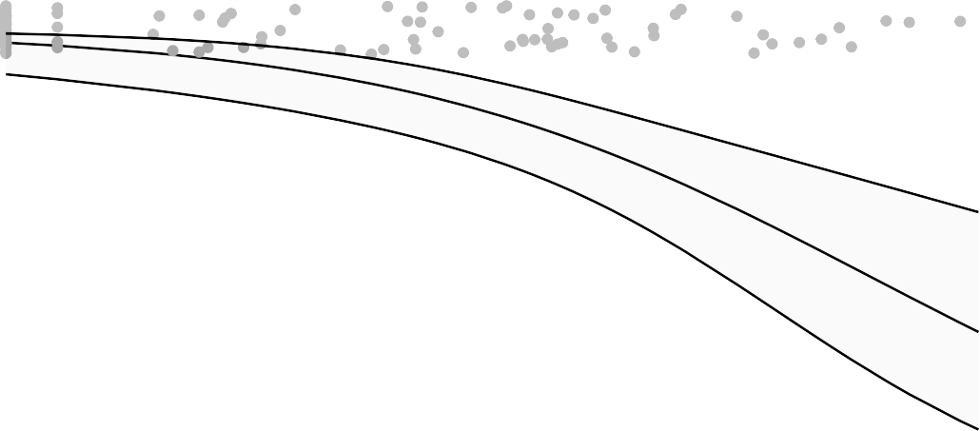
1.00
bin VL Day2 PostChallenge NasalSwab Subgenomic

0.75

0.50

0.25

0.00

log
bin VL Day2 PostChallenge NasalSwab Subgenomic
2 3 4
log PsVNA ID80 2 weeks prior challenge

Figure 6.4.143

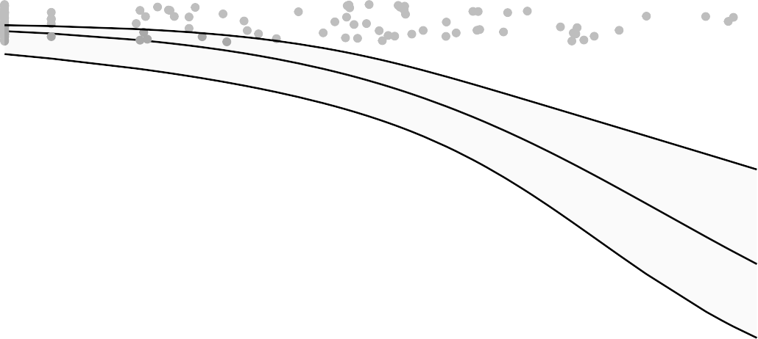
1.00

0.75

0.50

0.25

0.00

2 3 4

log PsVNA ID80 day challenge
Figure 6.4.144

